A PRACTICAL ASSIGNMENT
OF
“MCA 206 - Programming in Python”
Submitted in partial fulfillment of the requirements for the

Master of Computer Applications
MCA - IInd semester

From

PT. RAVISHANKAR SHUKLA UNIVERSITY SCHOOL OF STUDIES, RAIPUR(C.G)

Year: 2022-23



Guided By:- Submitted by :-
Mr. Rahul Singh Saumya Ranjan Nayak
(Ass. Professor ,C.S.&IT,PRSU)

Submitted to
( S. O. S. IN COMPUTER SCIENCE & IT, RAIPUR )
Pt.Ravishankar Shukla University Raipur (C.G.)

INDEX

S.No. | List of programs | Signature
1 | Program to perform arithmetic operations on integers
2 | Program to check and print the types of at least 5  different in- built objects
3 | Program to check if a number is EVEN or ODD
4 | Program to check if a number is Positive, Negative or  Zero
5 | Program to check if a number is PRIME or NOT
6 | Program to check whether a string is a valid decimal  number or not
7 | Program to check leap year
8 | Program to to check string is palindrome or not
9 | Program to convert into different number systems
10 | Program to find the sum of natural number unto N
11 | Program to get marks and calculate average marks
12 | Program to find sum and product of digits of number
13 | Program to find GCD and LCM
14 | Program to find factorial using while loop
15 | Program to print fibonacci series
16 | Program to print multiplication table
17 | Program to access each element of a string using  while loop
18 | Program to access each element of string using for  loop
19 | Program to find substring in the main string
20 | Program to find the first occurrence of a substring in  the main string
21 | Program to count the number of times a substring  appears in the main string
22 | Program to demonstrate the use of all casting  methods and display a string in different cases
23 | Program to demonstrate all string testing methods
24 | Program to take int list input and return average

S.No. | List of programs | Signature
25 | Function to print prime numbers between I/O
26 | Function to take two integers and return sum &  product
27 | Program to demonstrate positional arguments
28 | Program for keyword arguments of a function
29 | Program to demonstrate default arguments of function
30 | Program for variable length arguments
31 | Program to demonstrate keyword variable length
32 | Program to demonstrate global and local variables
33 | Program to find factorial using recursion
34 | Program to demonstrate lamda functions
35 | Program to demonstrate use of lambda functions and  map
36 | Program to demonstrate the use of lambda function  and reduce
37 | Program to demonstrate the various list procession  methods
38 | Program to find biggest and smallest numbers in list
39 | Program to find common elements in two list
40 | Program to demonstrate the various tuple procession  methods
41 | Program to demonstrate the use of dictionaries
42 | Program to find the number of occurrences of each  letter in string using dictionaries
43 | Program to print the CWD and change the CWD
44 | Program that takes a list of words from the user and  writes them into a file.
45 | Program that reads a file in text mode and counts the  number of words that contain
46 | Programs to demonstrate the creation and use of  “modules”
47 | Exception Handling Program that uses try and except
48 | Exception Handling Program that handles multiple  types of exceptions

S.No. | List of programs | Signature
49 | Exception Handling Program that uses try, except and  else.
50 | Exception Handling Program that uses finally with try.
51 | Program to create class
52 | Program that creates classes “Point” and “Rectangle”
53 | Program that creates a class Students which inherits  the properties of the “Person”
54 | Program to demonstrate “Multiple Inheritance”
55 | Program to demonstrate “Method Overriding”
56 | Program to demonstrate “Method Overloading”
57 | Program to demonstrate “Operator Overloading” [+  and -] using a class “Book”
58 | Use the “turtle” module to draw concentric circles  with different colours.
59 | Use the “turtle” module to print the multiplication  table.
60 | Use the “turtle” module to draw (not write) your  name.

Programming in Python MCA 2nd Semester

Practical No. 1
Program : Write a Python program to perform arithmetic operations on integers.

Code Section :
# Ask the user to input two integers
num1 = int(input("Enter the first integer: ")) num2 = int(input("Enter the second integer: "))

# Perform arithmetic operations sum = num1 + num2
difference = num1 - num2 product = num1 * num2 quotient = num1 / num2

# Print the results print("Sum: ", sum)
print("Difference: ", difference) print("Product: ", product) print("Quotient: ", quotient)

Saumya Ranjan Nayak Page 1

Programming in Python MCA 2nd Semester

Output Section :

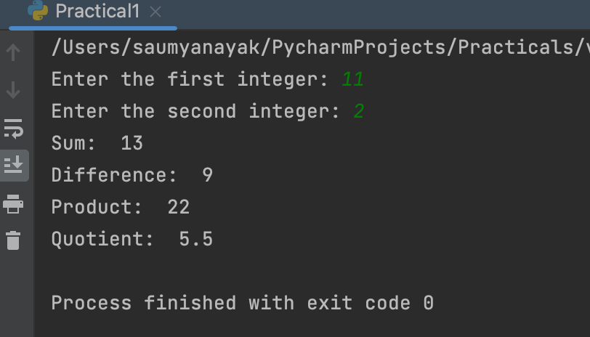

Saumya Ranjan Nayak Page 2

Programming in Python MCA 2nd Semester

Practical No. 2
Program : Write a Python program to check and print the types of at least 5 different in- built objects.

Code Section :
# Check and print the types of different built-in objects

# Integer num = 123
print("Type of", num, "is", type(num))

# Floating-point number float_num = 3.14
print("Type of", float_num, "is", type(float_num))

# Boolean is_true = True
print("Type of", is_true, "is", type(is_true))

# String
text = "Hello, World!"
print("Type of", text, "is", type(text))

# List
my_list = [1, 2, 3, "a", "b", "c"]
print("Type of", my_list, "is", type(my_list))

Saumya Ranjan Nayak Page 3

Programming in Python MCA 2nd Semester

Output Section :

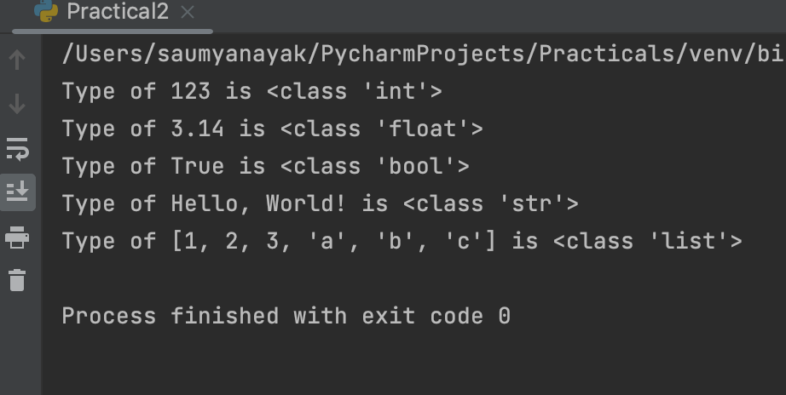

Saumya Ranjan Nayak Page 4

Programming in Python MCA 2nd Semester

Practical No. 3
Program : Write a Python program to check if a number is EVEN or ODD.

Code Section :
# Ask the user to input a number num = int(input("Enter a number: "))

# Check if the number is even or odd if num % 2 == 0:
print(num, "is even.") else:
print(num, "is odd.")

Saumya Ranjan Nayak Page 5

Programming in Python MCA 2nd Semester

Output Section :

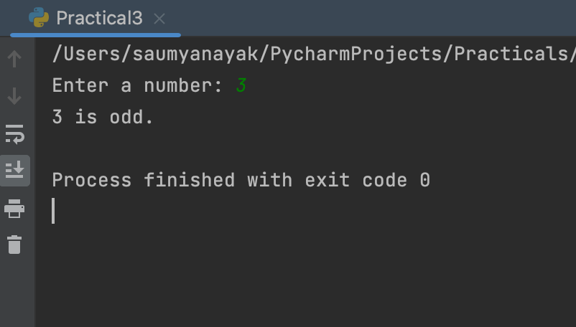

Saumya Ranjan Nayak Page 6

Programming in Python MCA 2nd Semester

Practical No. 4
Program : Write a Python program to check if a number is Positive, Negative or Zero.

Code Section :
# Ask the user to input a number
num = float(input("Enter a number: "))

# Check if the number is positive, negative, or zero if num > 0:
print(num, "is positive.") elif num < 0:
print(num, "is negative.") else:
print(num, "is zero.")

Saumya Ranjan Nayak Page 7

Programming in Python MCA 2nd Semester

Output Section :

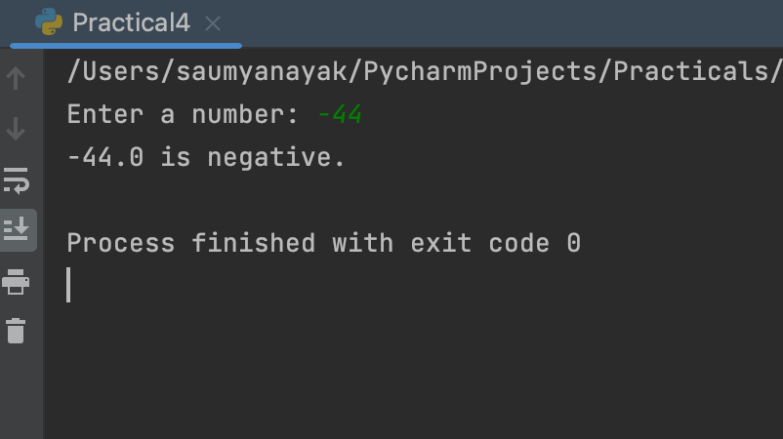

Saumya Ranjan Nayak Page 8

Programming in Python MCA 2nd Semester

Practical No. 5
Program : Write a Python program to check if a number is PRIME or NOT.

Code Section :
# Ask the user to input a number num = int(input("Enter a number: "))

# Check if the number is prime if num > 1:
# check for factors
for i in range(2, num): if num % i == 0:
print(num, "is not a prime number.") break
else:
print(num, "is a prime number.")

else:
print(num, "is not a prime number.")

Saumya Ranjan Nayak Page 9

Programming in Python MCA 2nd Semester

Output Section :

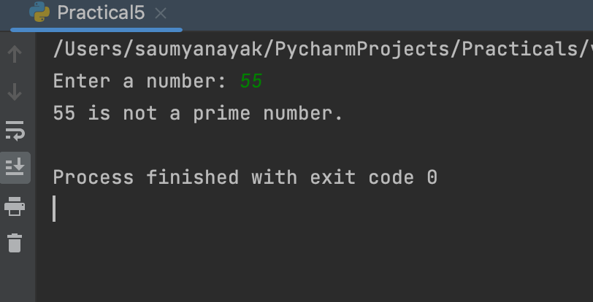

Saumya Ranjan Nayak Page 10

Programming in Python MCA 2nd Semester

Practical No. 6
Program : Write a Python program to check whether a string entered by the user is a valid decimal number or not.

Code Section :
# Ask the user to input a string str = input("Enter a string: ")

# Try to convert the string to a float try:
num = float(str)
print(str, "is a valid decimal number.") except ValueError:
print(str, "is not a valid decimal number.")

Saumya Ranjan Nayak Page 11

Programming in Python MCA 2nd Semester

Output Section :

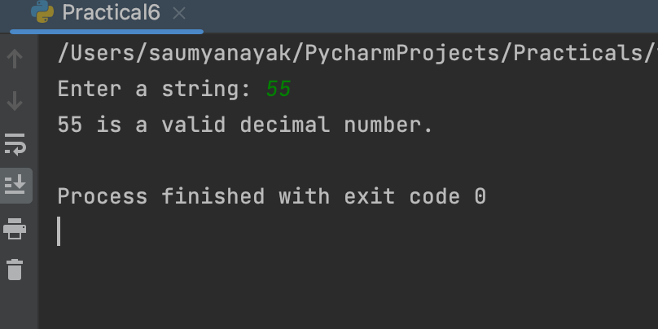

Saumya Ranjan Nayak Page 12

Programming in Python MCA 2nd Semester

Practical No. 7
Program : Write a Python program to check if a year entered by the user is a Leap Year or NOT.

Code Section :
# Ask the user to input a year year = int(input("Enter a year: "))

# Check if the year is a leap year
if (year % 4 == 0 and year % 100 != 0) or (year % 400 == 0): print(year, "is a leap year.")
else:
print(year, "is not a leap year.")

Saumya Ranjan Nayak Page 13

Programming in Python MCA 2nd Semester

Output Section :

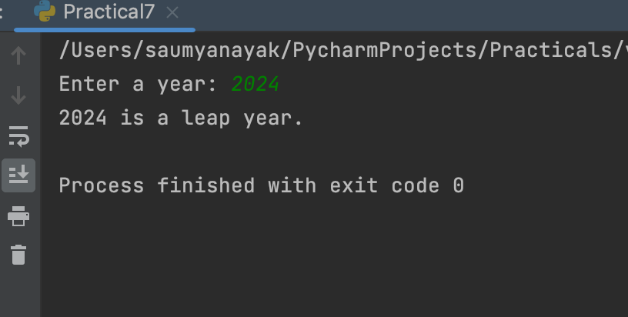

Saumya Ranjan Nayak Page 14

Programming in Python MCA 2nd Semester

Practical No. 8
Program : Write a Python program to check whether a string entered by the user is a palindrome or not.

Code Section :
# Ask the user to input a string str = input("Enter a string: ")

# Reverse the string rev_str = str[::-1]

# Check if the string is a palindrome if str == rev_str:
print(str, "is a palindrome.") else:
print(str, "is not a palindrome.")

Saumya Ranjan Nayak Page 15

Programming in Python MCA 2nd Semester

Output Section :

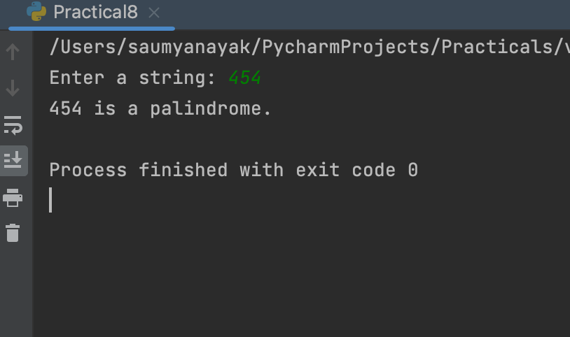

Saumya Ranjan Nayak Page 16

Programming in Python MCA 2nd Semester

Practical No. 9
Program : Write a Python program to get a Decimal number from user and convert it into Binary, Octal and Hexadecimal.

Code Section :
# Ask the user to input a decimal number decimal = int(input("Enter a decimal number: "))

# Convert the decimal number to binary, octal, and hexadecimal binary = bin(decimal)
octal = oct(decimal) hexadecimal = hex(decimal)

# Print the result print("Decimal:", decimal) print("Binary:", binary) print("Octal:", octal)
print("Hexadecimal:", hexadecimal)

Saumya Ranjan Nayak Page 17

Programming in Python MCA 2nd Semester

Output Section :

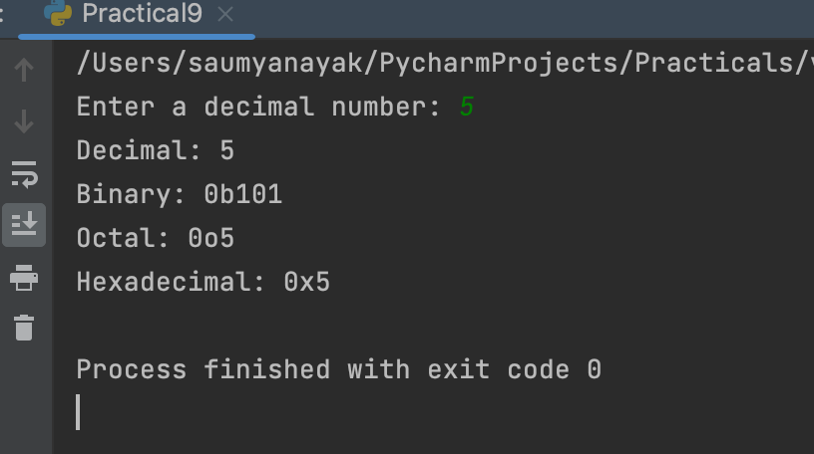

Saumya Ranjan Nayak Page 18

Programming in Python MCA 2nd Semester

Practical No. 10
Program : Write a Python program to find sum of natural numbers, up to N.

Code Section :
# Ask the user to input a number N = int(input("Enter a number: "))

# Initialize the sum to 0 sum = 0

# Use a loop to iterate from 1 to N and add each number to the sum for i in range(1, N+1):
sum += i

# Print the result
print("The sum of natural numbers up to", N, "is", sum)

Saumya Ranjan Nayak Page 19

Programming in Python MCA 2nd Semester

Output Section :

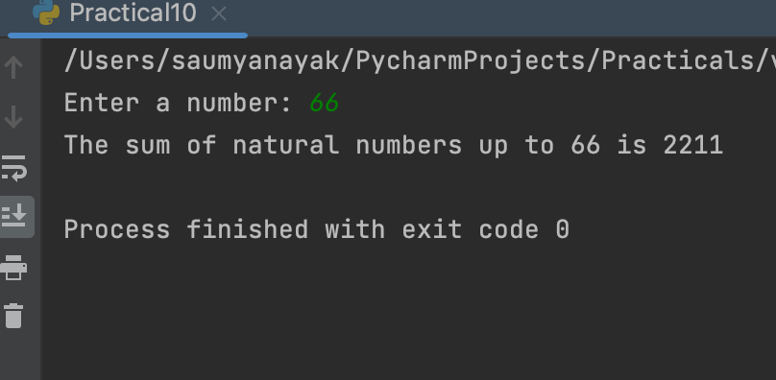

Saumya Ranjan Nayak Page 20

Programming in Python MCA 2nd Semester

Practical No. 11
Program : Write a Python program to get marks in five subjects from user and calculate average marks, percentage and grade of a student.

Code Section :
# Ask the user to input marks in five subjects subject1 = int(input("Enter marks in subject 1: ")) subject2 = int(input("Enter marks in subject 2: ")) subject3 = int(input("Enter marks in subject 3: ")) subject4 = int(input("Enter marks in subject 4: ")) subject5 = int(input("Enter marks in subject 5: "))

# Calculate the total marks and average marks
total_marks = subject1 + subject2 + subject3 + subject4 + subject5 average_marks = total_marks / 5

# Calculate the percentage
percentage = (total_marks / 500) * 100

# Determine the grade based on percentage if percentage >= 90:
grade = 'A+'
elif percentage >= 80: grade = 'A'
elif percentage >= 70: grade = 'B'
elif percentage >= 60:

Saumya Ranjan Nayak Page 21

Programming in Python MCA 2nd Semester

grade = 'C'
elif percentage >= 50: grade = 'D'
else:
grade = 'Fail'

# Print the result
print("Total marks:", total_marks) print("Average marks:", average_marks) print("Percentage:", percentage, "%") print("Grade:", grade)

Saumya Ranjan Nayak Page 22

Programming in Python MCA 2nd Semester

Output Section :

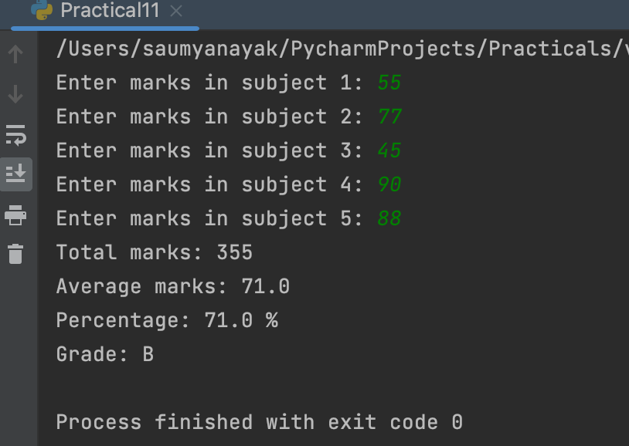

Saumya Ranjan Nayak Page 23

Programming in Python MCA 2nd Semester

Practical No. 12
Program : Write a Python program to get a number and find the sum and product of its digits.

Code Section :
# Ask the user to input a number number = int(input("Enter a number: "))

# Initialize the sum and product to 0 and 1 respectively sum = 0
product = 1

# Use a loop to iterate over each digit of the number while number > 0:
# Get the last digit of the number digit = number % 10

# Add the digit to the sum and multiply it to the product sum += digit
product *= digit

# Remove the last digit from the number number //= 10

# Print the result print("Sum of digits:", sum)
print("Product of digits:", product)

Saumya Ranjan Nayak Page 24

Programming in Python MCA 2nd Semester

Output Section :

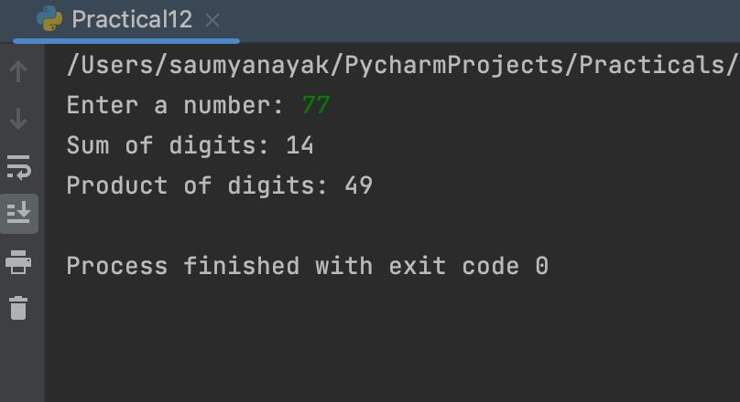

Saumya Ranjan Nayak Page 25

Programming in Python MCA 2nd Semester

Practical No. 13
Program : Write a Python program to get two integers and find their GCD and LCM.

Code Section :
# Function to find GCD of two numbers def gcd(a, b):
if b == 0: return a
else:
return gcd(b, a % b)

# Function to find LCM of two numbers def lcm(a, b):
return (a * b) // gcd(a, b)

# Get two integers from the user
num1 = int(input("Enter the first number: ")) num2 = int(input("Enter the second number: "))

# Calculate the GCD and LCM gcd_value = gcd(num1, num2) lcm_value = lcm(num1, num2)

# Print the results
print("GCD of", num1, "and", num2, "is:", gcd_value)
print("LCM of", num1, "and", num2, "is:", lcm_value)

Saumya Ranjan Nayak Page 26

Programming in Python MCA 2nd Semester

Output Section :

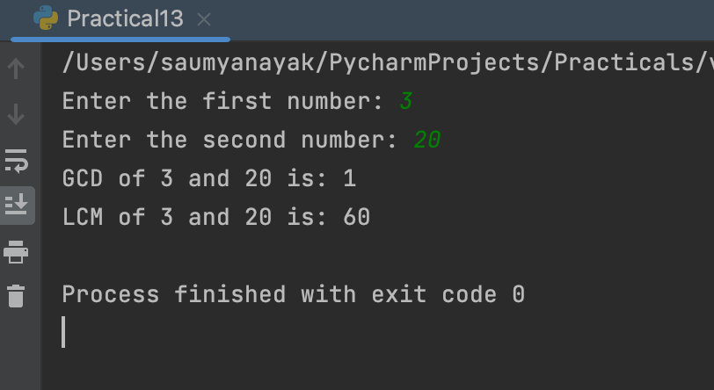

Saumya Ranjan Nayak Page 27

Programming in Python MCA 2nd Semester

Practical No. 14
Program : Write a Python program to find factorial of a number using while loop.

Code Section :
# Get the input from the user
num = int(input("Enter a number: "))

# Initialize the factorial to 1 factorial = 1

# Use a while loop to calculate the factorial while num > 0:
factorial *= num num -= 1

# Print the result print("Factorial:", factorial)

Saumya Ranjan Nayak Page 28

Programming in Python MCA 2nd Semester

Output Section :

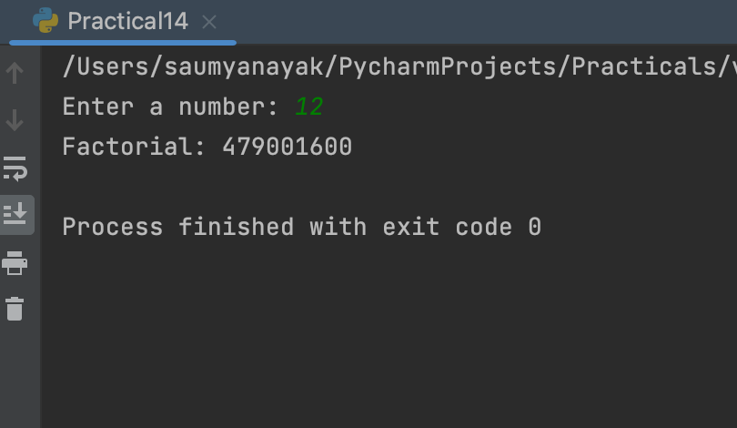

Saumya Ranjan Nayak Page 29

Programming in Python MCA 2nd Semester

Practical No. 15
Program : Write a Python program to print Fibonacci series up to N terms.

Code Section :
# Get the input from the user
num_terms = int(input("Enter the number of terms: "))

# Initialize the first two terms of the series a = 0
b = 1

# Use a loop to generate the series for i in range(num_terms):
print(a, end=" ") c = a + b
a = b b = c

Saumya Ranjan Nayak Page 30

Programming in Python MCA 2nd Semester

Output Section :

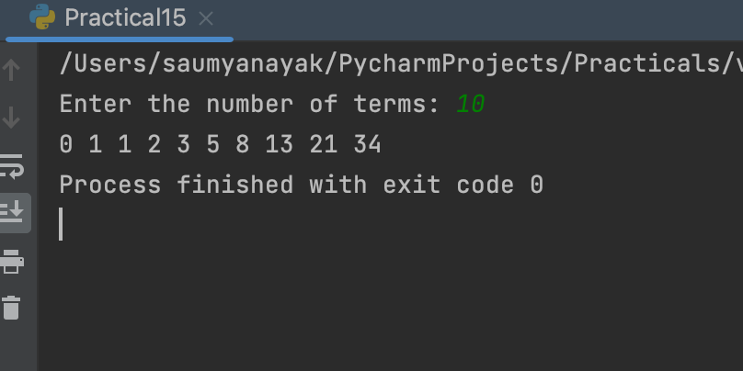

Saumya Ranjan Nayak Page 31

Programming in Python MCA 2nd Semester

Practical No. 16
Program : Write a Python program to print multiplication table.

Code Section :
# Get the input from the user
num = int(input("Enter a number: "))

# Print the multiplication table print("Multiplication table of", num, ":")

for i in range(1, 11):
print(num, "x", i, "=", num * i)

Saumya Ranjan Nayak Page 32

Programming in Python MCA 2nd Semester

Output Section :

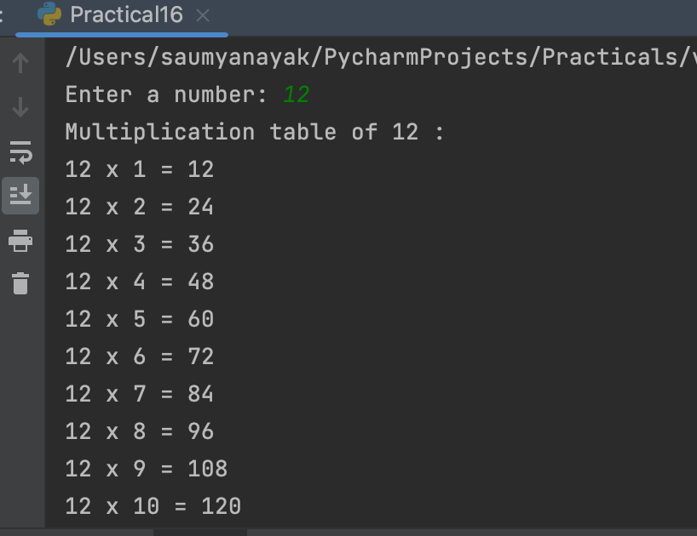

Saumya Ranjan Nayak Page 33

Programming in Python MCA 2nd Semester

Practical No. 17
Program : Write a Python program to access each element of a string in forward and backward orders using the ‘while’ loop.

Code Section :
# Get the input from the user string = input("Enter a string: ")

# Access each element of the string in forward order print("Forward order:")

i = 0
while i < len(string): print(string[i])
i += 1

# Access each element of the string in backward order print("\nBackward order:")

i = len(string) - 1 while i >= 0:
print(string[i]) i -= 1

Saumya Ranjan Nayak Page 34

Programming in Python MCA 2nd Semester

Output Section :

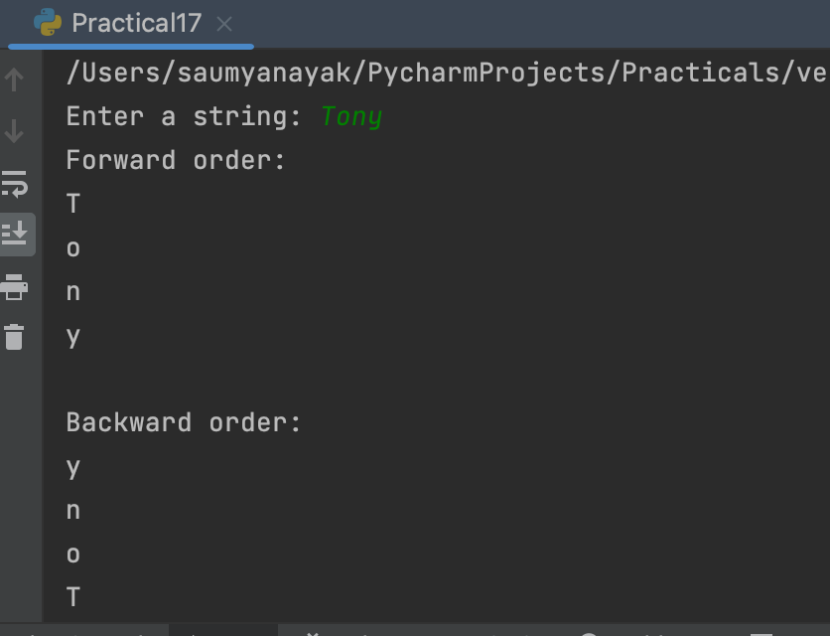

Saumya Ranjan Nayak Page 35

Programming in Python MCA 2nd Semester

Practical No. 18
Program : Write a Python program to access each element of a string in forward and backward orders using the ‘for’ loop.

Code Section :
# Get the input from the user string = input("Enter a string: ")

# Access each element of the string in forward order print("Forward order:")

for char in string: print(char)

# Access each element of the string in backward order print("\nBackward order:")

for char in reversed(string): print(char)

Saumya Ranjan Nayak Page 36

Programming in Python MCA 2nd Semester

Output Section :

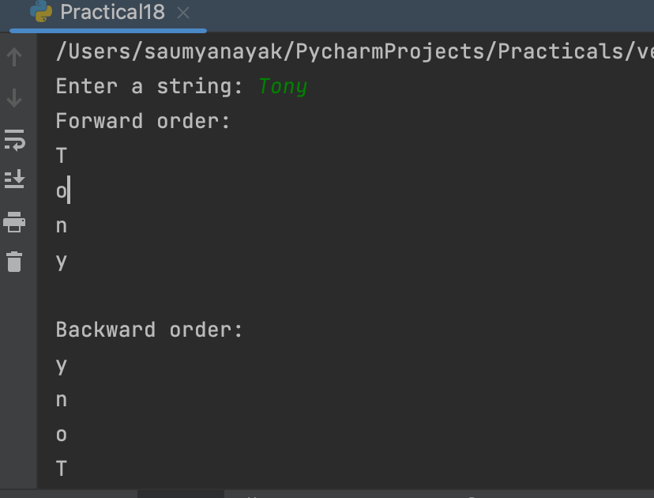

Saumya Ranjan Nayak Page 37

Programming in Python MCA 2nd Semester

Practical No. 19
Program : Write a Python program to find whether a substring exists in main string or not.

Code Section :
# Get the input from the user
main_string = input("Enter the main string: ") sub_string = input("Enter the sub string: ")

# Check if the sub string exists in the main string if sub_string in main_string:
print(f"The sub string '{sub_string}' exists in the main string '{main_string}'") else:
print(f"The sub string '{sub_string}' does not exist in the main string '{main_string}'")

Saumya Ranjan Nayak Page 38

Programming in Python MCA 2nd Semester

Output Section :

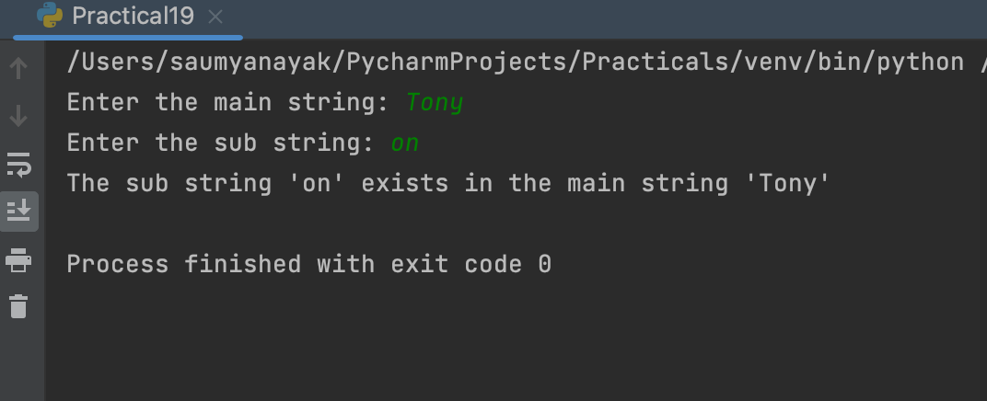

Saumya Ranjan Nayak Page 39

Programming in Python MCA 2nd Semester

Practical No. 20
Program : Write a Python program to find the first occurrence of a substring in the main string.

Code Section :
# Get the input from the user
main_string = input("Enter the main string: ") sub_string = input("Enter the sub string: ")

# Find the first occurrence of the sub string in the main string index = main_string.find(sub_string)

# Check if the sub string was found in the main string if index != -1:
print(f"The sub string '{sub_string}' was found in the main string '{main_string}' at index {index}")
else:
print(f"The sub string '{sub_string}' was not found in the main string '{main_string}'")

Saumya Ranjan Nayak Page 40

Programming in Python MCA 2nd Semester

Output Section :

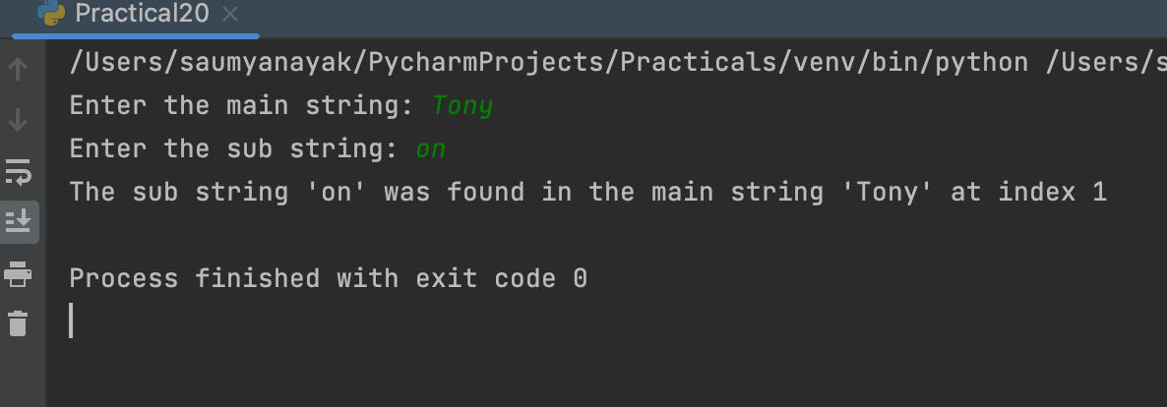

Saumya Ranjan Nayak Page 41

Programming in Python MCA 2nd Semester

Practical No. 21
Program : Write a Python program to count the number of times a substring appears in the main string.

Code Section :
# Get the input from the user
main_string = input("Enter the main string: ") sub_string = input("Enter the sub string: ")

# Count the number of occurrences of the sub string in the main string count = main_string.count(sub_string)

# Print the result
print(f"The sub string '{sub_string}' appears {count} times in the main string '{main_string}'")

Saumya Ranjan Nayak Page 42

Programming in Python MCA 2nd Semester

Output Section :

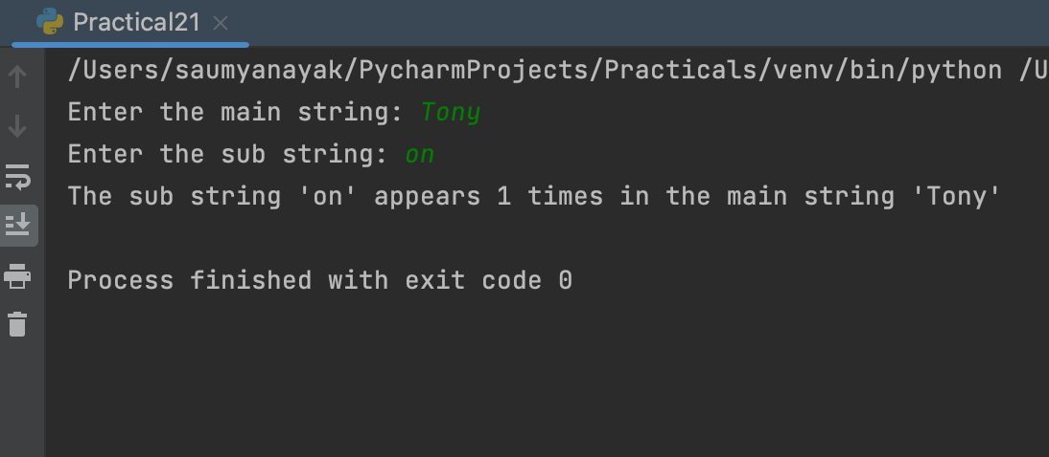

Saumya Ranjan Nayak Page 43

Programming in Python MCA 2nd Semester

Practical No. 22
Program : Write a Python program to demonstrate the use of all “casing” methods and display a string in different cases.

Code Section :
# Get the input from the user input_string = input("Enter a string: ")

# Convert the string to different cases using casing methods uppercase_string = input_string.upper()
lowercase_string = input_string.lower() titlecase_string = input_string.title() capitalized_string = input_string.capitalize() swapcase_string = input_string.swapcase()

# Print the string in different cases print(f"The original string is: {input_string}")
print(f"The string in uppercase is: {uppercase_string}") print(f"The string in lowercase is: {lowercase_string}") print(f"The string in titlecase is: {titlecase_string}") print(f"The string in capitalized form is: {capitalized_string}") print(f"The string with swapped cases is: {swapcase_string}")

Saumya Ranjan Nayak Page 44

Programming in Python MCA 2nd Semester

Output Section :

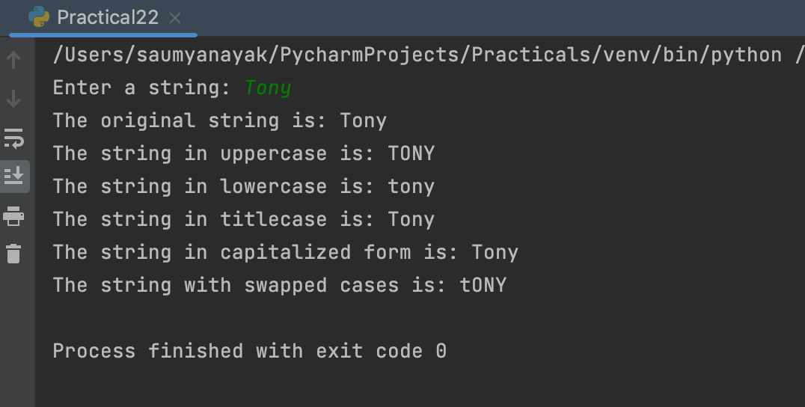

Saumya Ranjan Nayak Page 45

Programming in Python MCA 2nd Semester

Practical No. 23
Program : Write a Python program to demonstrate the use of all string testing
{isXXX()} methods.

Code Section :
# Get the input from the user input_string = input("Enter a string: ")

# Use string testing methods to check different properties of the string print(f"Is the string alphanumeric? {input_string.isalnum()}") print(f"Is the string alphabetic? {input_string.isalpha()}")
print(f"Is the string decimal? {input_string.isdecimal()}") print(f"Is the string a digit? {input_string.isdigit()}")
print(f"Is the string an identifier? {input_string.isidentifier()}") print(f"Is the string lowercase? {input_string.islower()}") print(f"Is the string numeric? {input_string.isnumeric()}") print(f"Is the string printable? {input_string.isprintable()}") print(f"Is the string whitespace? {input_string.isspace()}") print(f"Is the string titlecased? {input_string.istitle()}") print(f"Is the string uppercase? {input_string.isupper()}")

Saumya Ranjan Nayak Page 46

Programming in Python MCA 2nd Semester

Output Section :

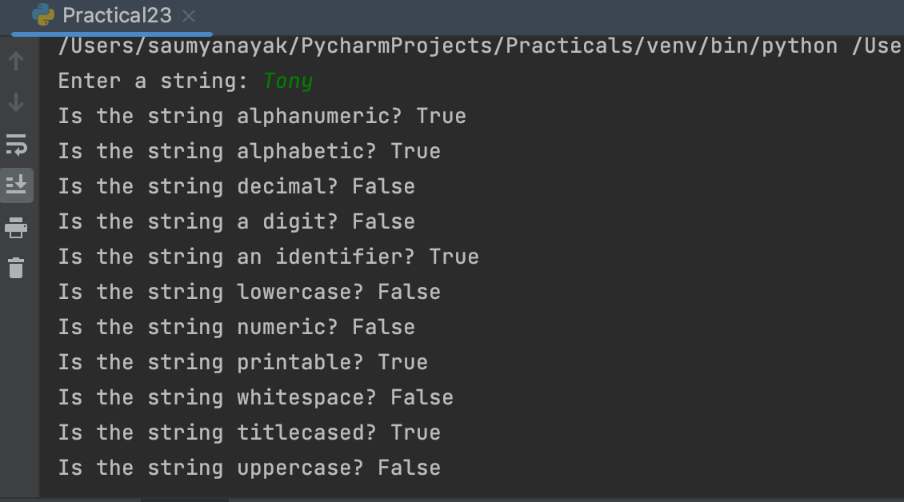

Saumya Ranjan Nayak Page 47

Programming in Python MCA 2nd Semester

Practical No. 24
Program : Write a Python function to take a list of integers as input and return the average.

Code Section :
def find_average(lst): if len(lst) == 0:
return 0 else:
return sum(lst) / len(lst)

lst = [5, 10, 15, 20, 25]
average = find_average(lst) print(f"The average is {average}")

Saumya Ranjan Nayak Page 48

Programming in Python MCA 2nd Semester

Output Section :

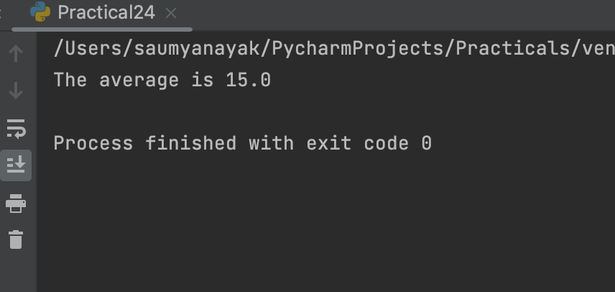

Saumya Ranjan Nayak Page 49

Programming in Python MCA 2nd Semester

Practical No. 25
Program : Write a Python function to take two distinct integers as input and print all prime numbers between them.

Code Section :
def print_primes_between(num1, num2): for num in range(num1, num2 + 1):
if num > 1:
for i in range(2, num): if (num % i) == 0:
break

else:
print(num)

print_primes_between(10, 30)

Saumya Ranjan Nayak Page 50

Programming in Python MCA 2nd Semester

Output Section :

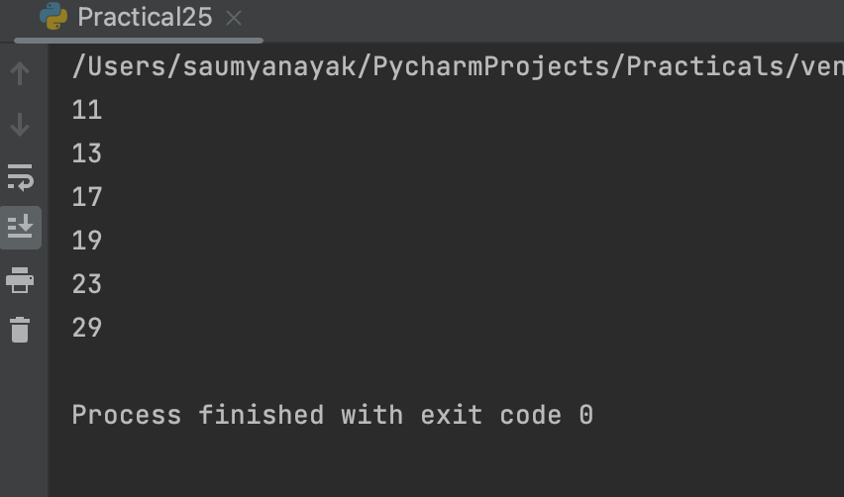

Saumya Ranjan Nayak Page 51

Programming in Python MCA 2nd Semester

Practical No. 26
Program : Write a Python function to take two integers as input and return both their sum and product.

Code Section :
def sum_and_product(num1, num2): sum = num1 + num2
product = num1 * num2 return sum, product

result = sum_and_product(3, 5) print("Sum:", result[0]) print("Product:", result[1])

Saumya Ranjan Nayak Page 52

Programming in Python MCA 2nd Semester

Output Section :

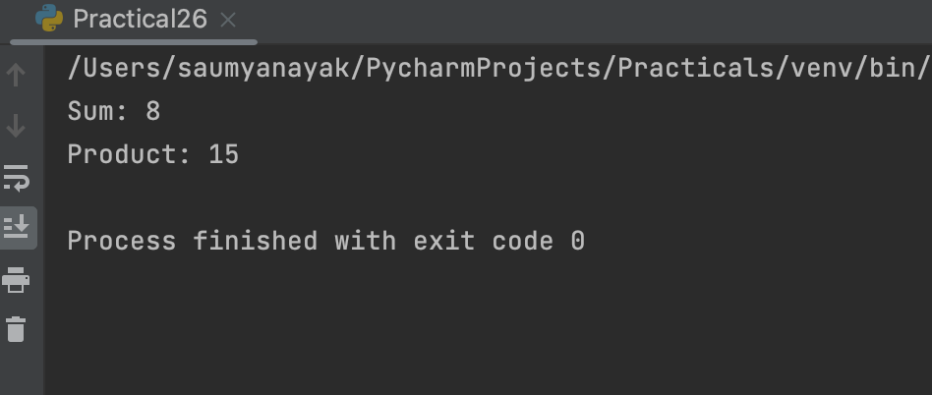

Saumya Ranjan Nayak Page 53

Programming in Python MCA 2nd Semester

Practical No. 27
Program : Write a Python program to demonstrate the positional arguments of a function.

Code Section :
def add_numbers(a, b): sum = a + b
return sum

result = add_numbers(3, 5) print("The sum of 3 and 5 is:", result)

Saumya Ranjan Nayak Page 54

Programming in Python MCA 2nd Semester

Output Section :

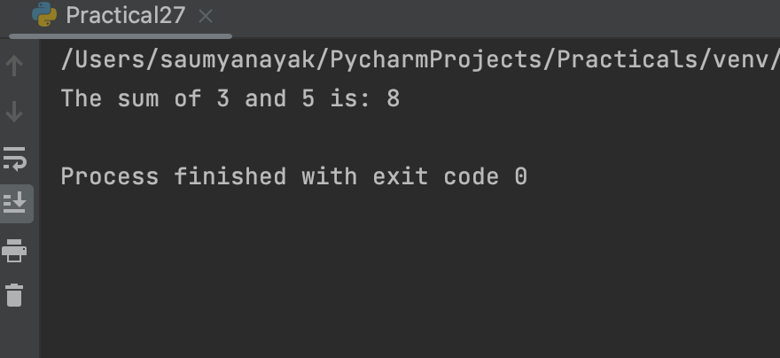

Saumya Ranjan Nayak Page 55

Programming in Python MCA 2nd Semester

Practical No. 28
Program : Write a Python program to demonstrate the keyword arguments of a function.

Code Section :
def describe_person(name, age, city):
print(f"{name} is {age} years old and lives in {city}.")

# calling the function using positional arguments describe_person("Alice", 25, "New York")

# calling the function using keyword arguments describe_person(name="Bob", age=30, city="Los Angeles")

Saumya Ranjan Nayak Page 56

Programming in Python MCA 2nd Semester

Output Section :

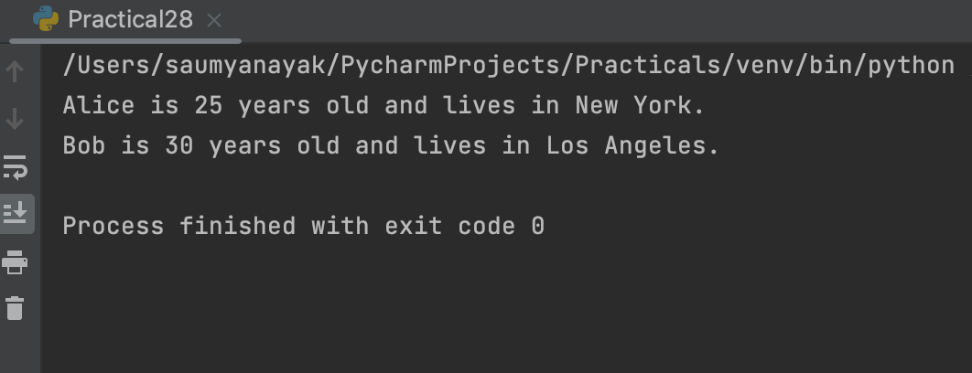

Saumya Ranjan Nayak Page 57

Programming in Python MCA 2nd Semester

Practical No. 29
Program : Write a Python program to demonstrate the default arguments of a function.

Code Section :
def greet(name, greeting="Hello"): print(greeting + ", " + name)

# Call the function with one argument greet("John") # Output: Hello, John

# Call the function with two arguments greet("Emily", "Hi") # Output: Hi, Emily

Saumya Ranjan Nayak Page 58

Programming in Python MCA 2nd Semester

Output Section :

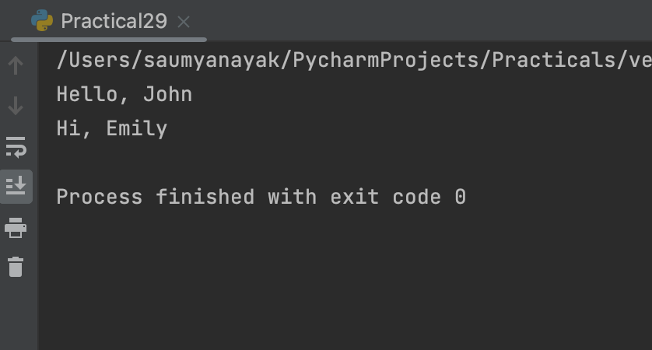

Saumya Ranjan Nayak Page 59

Programming in Python MCA 2nd Semester

Practical No. 30
Program : Write a Python function to demonstrate variable length arguments.

Code Section :
def add_numbers(*args): total = 0
for num in args: total += num
return total

# Call the function with different number of arguments print(add_numbers(1, 2, 3)) # Output: 6
print(add_numbers(4, 5, 6, 7)) # Output: 22 print(add_numbers(8)) # Output: 8

Saumya Ranjan Nayak Page 60

Programming in Python MCA 2nd Semester

Output Section :

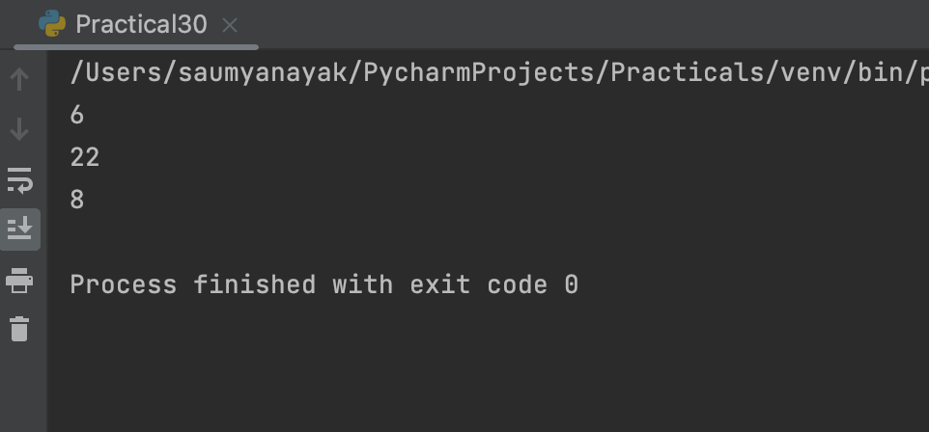

Saumya Ranjan Nayak Page 61

Programming in Python MCA 2nd Semester

Practical No. 31
Program : Write a Python function to demonstrate keyword variable length arguments.

Code Section :
def person_details(**kwargs): print("Personal Details:")
for key, value in kwargs.items(): print(f"{key}: {value}")

# Call the function with different keyword arguments person_details(name="John Doe", age=30, city="New York") person_details(name="Jane Doe", country="Canada")

Saumya Ranjan Nayak Page 62

Programming in Python MCA 2nd Semester

Output Section :

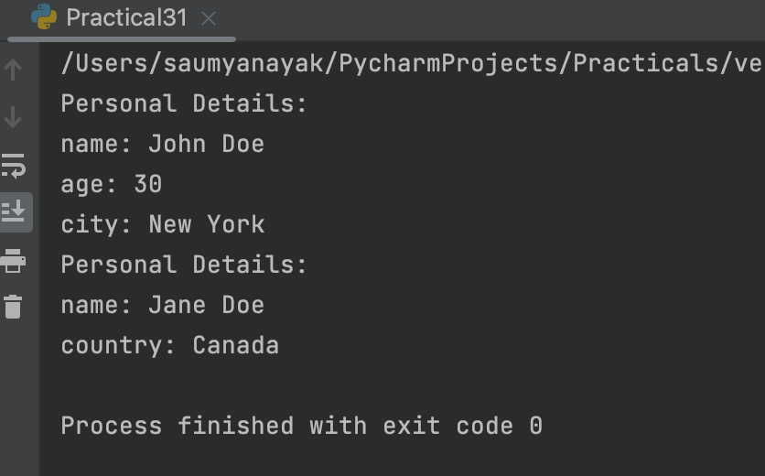

Saumya Ranjan Nayak Page 63

Programming in Python MCA 2nd Semester

Practical No. 32
Program : Write a Python program to demonstrate global and local variables.

Code Section :
# Global variable global_var = 10

def func():
# Local variable local_var = 5
# Accessing the global variable within the function print("Inside the function - global_var:", global_var) # Accessing the local variable within the function print("Inside the function - local_var:", local_var)

# Call the function func()

# Accessing the global variable outside the function print("Outside the function - global_var:", global_var)

# Trying to access the local variable outside the function raises an error #print("Outside the function - local_var:", local_var)

Saumya Ranjan Nayak Page 64

Programming in Python MCA 2nd Semester

Output Section :

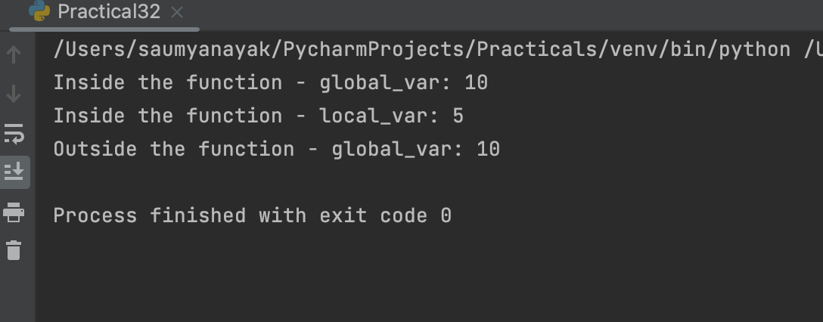

Saumya Ranjan Nayak Page 65

Programming in Python MCA 2nd Semester

Practical No. 33
Program : Write a Python function that takes an integer as input and calculates its factorial using recursion.

Code Section :
def factorial(n): if n == 0:
return 1 else:
return n * factorial(n-1)

print(factorial(5)) # Output: 120 print(factorial(0)) # Output: 1 print(factorial(10)) # Output: 3628800

Saumya Ranjan Nayak Page 66

Programming in Python MCA 2nd Semester

Output Section :

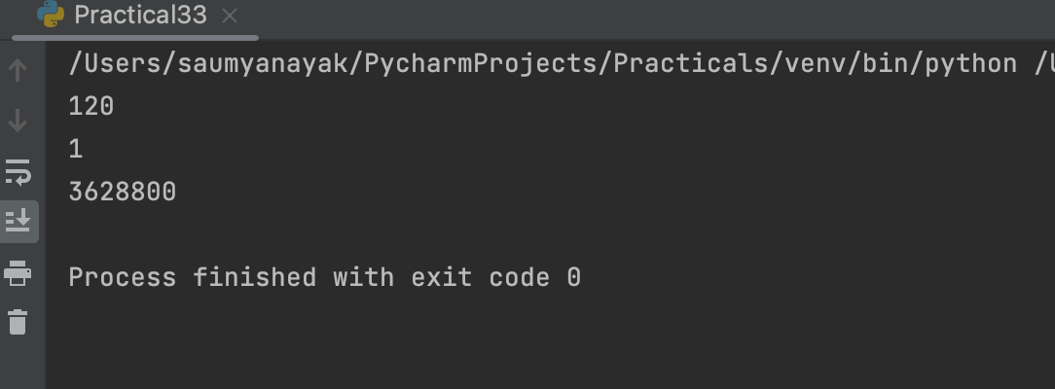

Saumya Ranjan Nayak Page 67

Programming in Python MCA 2nd Semester

Practical No. 34
Program : Write a Python program to demonstrate the use of lambda functions.

Code Section :
# Example 1: Lambda function to add two numbers add = lambda x, y: x + y
print(add(3, 5)) # Output: 8

# Example 2: Lambda function to check if a number is even is_even = lambda x: x % 2 == 0
print(is_even(4)) # Output: True

# Example 3: Sorting a list of strings by their length using lambda function fruits = ['apple', 'banana', 'orange', 'mango']
sorted_fruits = sorted(fruits, key=lambda x: len(x)) print(sorted_fruits) # Output: ['mango', 'apple', 'banana', 'orange']

Saumya Ranjan Nayak Page 68

Programming in Python MCA 2nd Semester

Output Section :

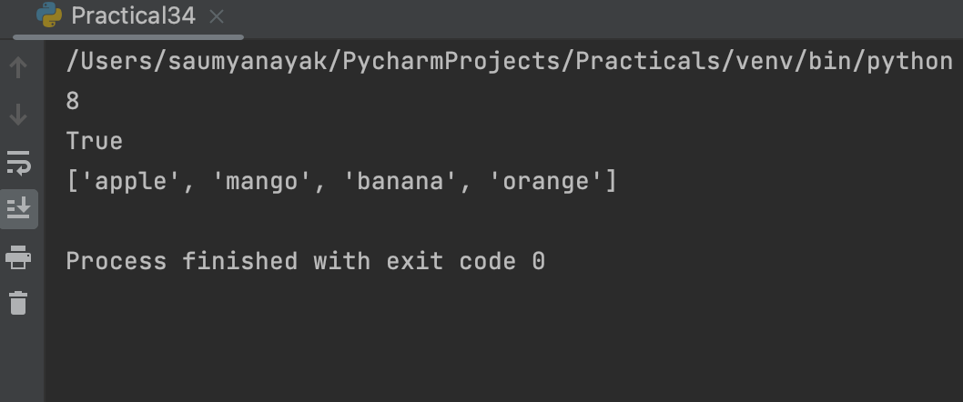

Saumya Ranjan Nayak Page 69

Programming in Python MCA 2nd Semester

Practical No. 35
Program : Write a Python program to demonstrate the use of lambda functions and map.

Code Section :
# Define a list of numbers numbers = [1, 2, 3, 4, 5]

# Use lambda function and map to square each number in the list squared_numbers = list(map(lambda x: x**2, numbers))

# Print the squared numbers print(squared_numbers)

Saumya Ranjan Nayak Page 70

Programming in Python MCA 2nd Semester

Output Section :

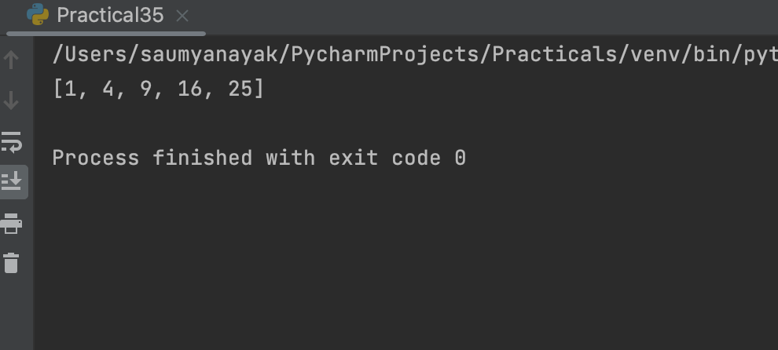

Saumya Ranjan Nayak Page 71

Programming in Python MCA 2nd Semester

Practical No. 36
Program : Write a Python program to demonstrate the use of lambda functions and reduce.

Code Section :
from functools import reduce

# using lambda functions with reduce to calculate the product of a list of numbers nums = [1, 2, 3, 4, 5]
product = reduce(lambda x, y: x * y, nums) print(f"Product of {nums} = {product}")

# using lambda functions with reduce to concatenate a list of strings strings = ["Python", "is", "awesome"]
result = reduce(lambda x, y: x + " " + y, strings) print(f"Concatenated string: {result}")

Saumya Ranjan Nayak Page 72

Programming in Python MCA 2nd Semester

Output Section :

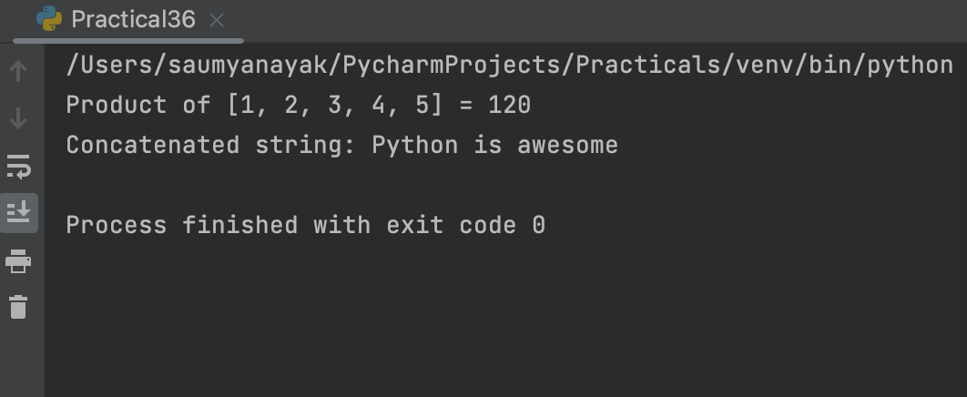

Saumya Ranjan Nayak Page 73

Programming in Python MCA 2nd Semester

Practical No. 37
Program : Write a Python program to demonstrate the various list processing methods.

Code Section :
# create a list of integers nums = [1, 2, 3, 4, 5]

# print the length of the list print("Length of the list:", len(nums))

# print the sum of the list print("Sum of the list:", sum(nums))

# print the maximum value in the list print("Maximum value in the list:", max(nums))

# print the minimum value in the list print("Minimum value in the list:", min(nums))

# add a new element to the end of the list nums.append(6)
print("List after appending a new element:", nums)

# insert a new element at a specific position in the list nums.insert(2, 10)
print("List after inserting a new element:", nums)

Saumya Ranjan Nayak Page 74

Programming in Python MCA 2nd Semester

# remove the first occurrence of an element in the list nums.remove(2)
print("List after removing an element:", nums)

# sort the list in ascending order nums.sort()
print("List in ascending order:", nums)

# sort the list in descending order nums.sort(reverse=True)
print("List in descending order:", nums)

# reverse the order of the list nums.reverse()
print("List in reverse order:", nums)

# create a copy of the list new_nums = nums.copy() print("New list:", new_nums)

# clear all elements from the list nums.clear()
print("List after clearing all elements:", nums)

Saumya Ranjan Nayak Page 75

Programming in Python MCA 2nd Semester

Output Section :

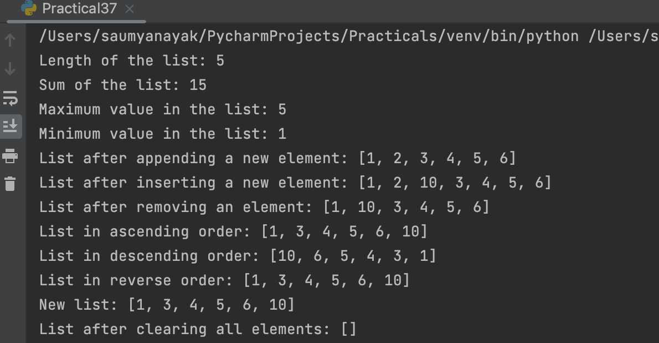

Saumya Ranjan Nayak Page 76

Programming in Python MCA 2nd Semester

Practical No. 38
Program : Write a Python program to find the biggest and smallest numbers in a list of integers.

Code Section :
def find_largest_smallest(numbers): largest = max(numbers)
smallest = min(numbers) return largest, smallest

numbers = [12, 3, 45, 6, 78, 90, 23]
largest, smallest = find_largest_smallest(numbers)

print("The largest number is:", largest) print("The smallest number is:", smallest)

Saumya Ranjan Nayak Page 77

Programming in Python MCA 2nd Semester

Output Section :

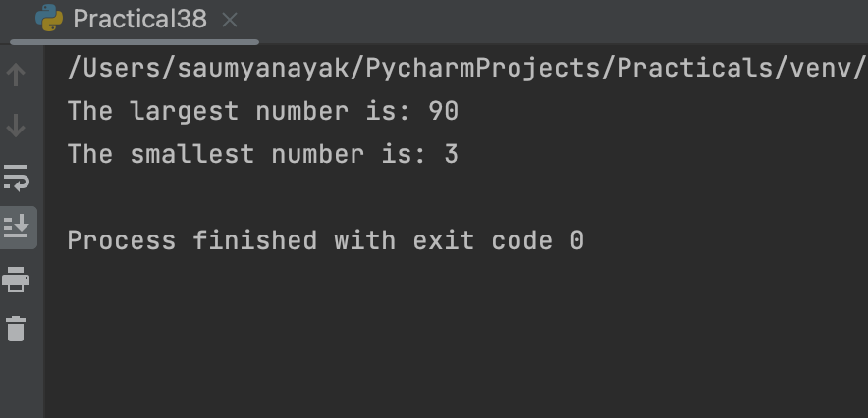

Saumya Ranjan Nayak Page 78

Programming in Python MCA 2nd Semester

Practical No. 39
Program : Write a Python program to find common elements in two lists.

Code Section :
def common_elements(list1, list2): set1 = set(list1)
set2 = set(list2)
common = list(set1.intersection(set2)) return common

# Example usage list1 = [1, 2, 3, 4, 5]
list2 = [3, 4, 5, 6, 7]
print(common_elements(list1, list2)) # Output: [3, 4, 5]

Saumya Ranjan Nayak Page 79

Programming in Python MCA 2nd Semester

Output Section :

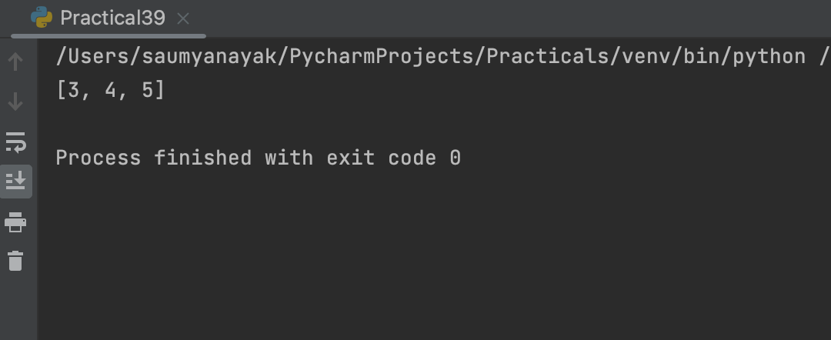

Saumya Ranjan Nayak Page 80

Programming in Python MCA 2nd Semester

Practical No. 40
Program : Write a Python program to demonstrate the various tuple processing methods.

Code Section :
# create a tuple my_tuple = (1, 3, 5, 7, 9)

# access elements of tuple using indexing print(my_tuple[0]) # 1
print(my_tuple[2]) # 5

# slicing
print(my_tuple[1:4]) # (3, 5, 7)

# length of tuple print(len(my_tuple)) # 5

# convert tuple to list my_list = list(my_tuple)
print(my_list) # [1, 3, 5, 7, 9]

# count number of occurrences of an element print(my_tuple.count(5)) # 1

# index of the first occurrence of an element print(my_tuple.index(7)) # 3
Saumya Ranjan Nayak Page 81

Programming in Python MCA 2nd Semester

# unpacking a tuple
a, b, c, d, e = my_tuple print(a, b, c, d, e) # 1 3 5 7 9

# combining tuples tuple1 = (1, 2, 3)
tuple2 = (4, 5, 6)
combined_tuple = tuple1 + tuple2 print(combined_tuple) # (1, 2, 3, 4, 5, 6)

Saumya Ranjan Nayak Page 82

Programming in Python MCA 2nd Semester

Output Section :

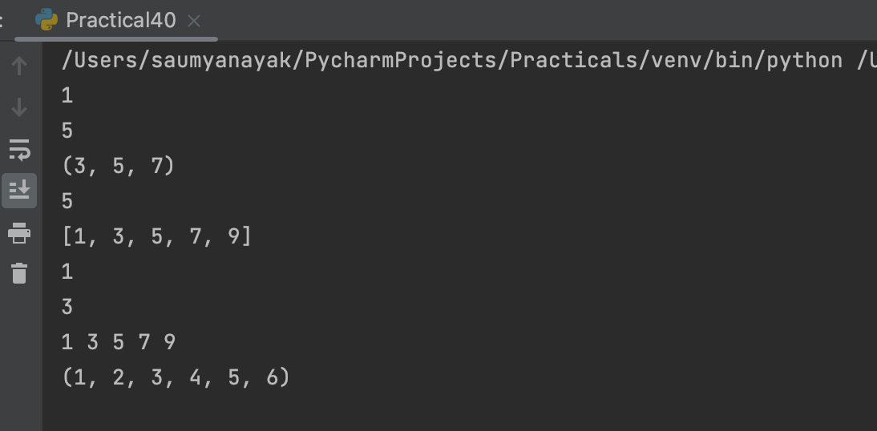

Saumya Ranjan Nayak Page 83

Programming in Python MCA 2nd Semester

Practical No. 41
Program : Write a Python program to demonstrate the use of dictionaries.

Code Section :
# Define a dictionary with some key-value pairs person = {'name': 'John', 'age': 30, 'city': 'New York'}

# Accessing dictionary values using keys print(person['name']) # Output: John print(person['age']) # Output: 30 print(person['city']) # Output: New York
# Adding a new key-value pair to the dictionary person['occupation'] = 'Software Engineer'
print(person) # Output: {'name': 'John', 'age': 30, 'city': 'New York', 'occupation': 'Software Engineer'}
# Modifying an existing value in the dictionary person['age'] = 35
print(person) # Output: {'name': 'John', 'age': 35, 'city': 'New York', 'occupation': 'Software Engineer'}
# Removing a key-value pair from the dictionary del person['occupation']
print(person) # Output: {'name': 'John', 'age': 35, 'city': 'New York'} # Looping through all the keys in a dictionary
for key in person: print(key, person[key])

Saumya Ranjan Nayak Page 84

Programming in Python MCA 2nd Semester

Output Section :

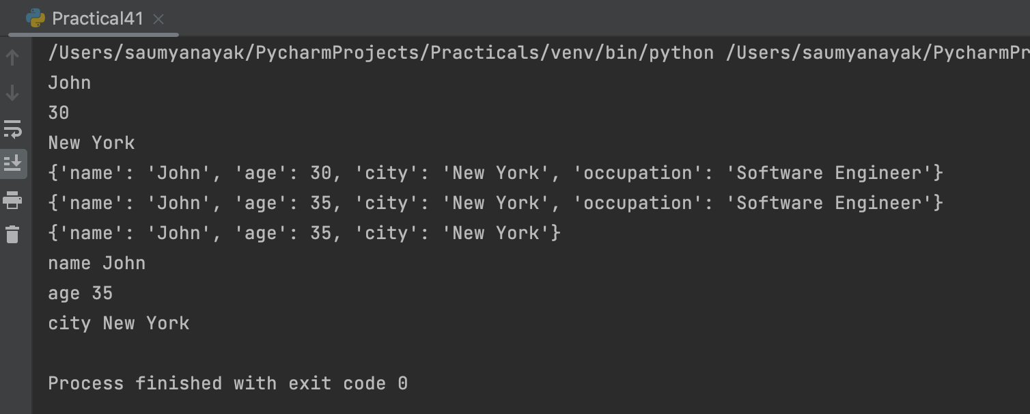

Saumya Ranjan Nayak Page 85

Programming in Python MCA 2nd Semester

Practical No. 42
Program : Write a Python program to find the number of occurrences of each letter in a string using dictionaries.

Code Section :
string = input("Enter a string: ") count = {}

for letter in string: if letter in count:
count[letter] += 1 else:
count[letter] = 1

print("The number of occurrences of each letter in the string:") for letter, num in count.items():
print(letter, ":", num)

Saumya Ranjan Nayak Page 86

Programming in Python MCA 2nd Semester

Output Section :

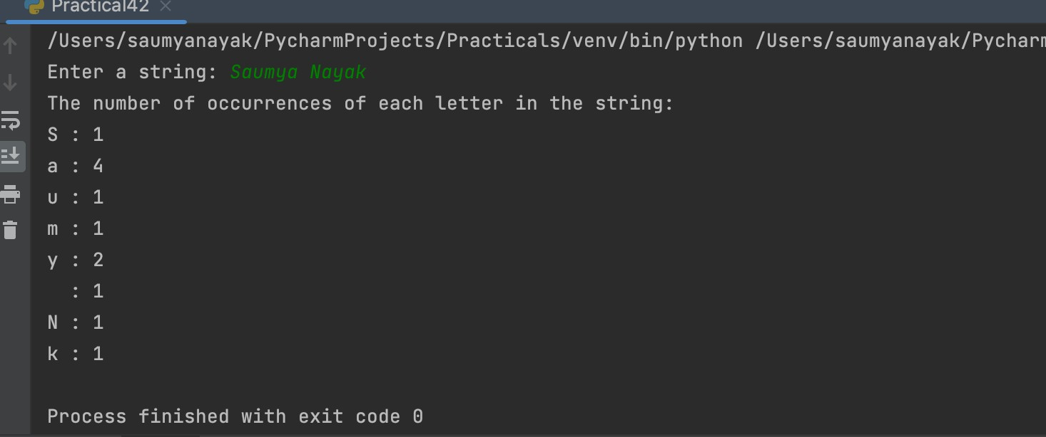

Saumya Ranjan Nayak Page 87

Programming in Python MCA 2nd Semester

Practical No. 43
Program : Write a Python program to print the CWD and change the CWD.

Code Section :
import os

# Print the current working directory print("Current working directory:", os.getcwd())

# Change the current working directory new_dir = input("Enter new directory path: ") os.chdir(new_dir)

# Print the updated current working directory print("Updated working directory:", os.getcwd())

Saumya Ranjan Nayak Page 88

Programming in Python MCA 2nd Semester

Output Section :

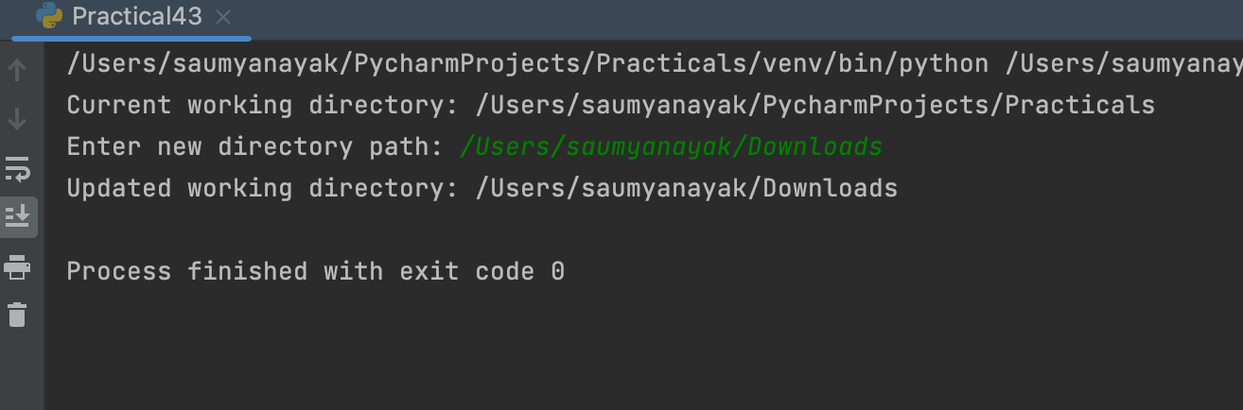

Saumya Ranjan Nayak Page 89

Programming in Python MCA 2nd Semester

Practical No. 44
Program : Write a Python program that takes a list of words from the user and writes them into a file. The program should stop when the user enters the word ‘quit’.

Code Section :
filename = 'words.txt'

# Open the file in write mode with open(filename, 'w') as file:

# Loop until the user enters 'quit' while True:
word = input("Enter a word: ")

# Write the word to the file file.write(word + '\n')

# If the user enters 'quit', break out of the loop if word == 'quit':
break

print(f"The words have been written to the file '{filename}'.")

Saumya Ranjan Nayak Page 90

Programming in Python MCA 2nd Semester

Output Section :

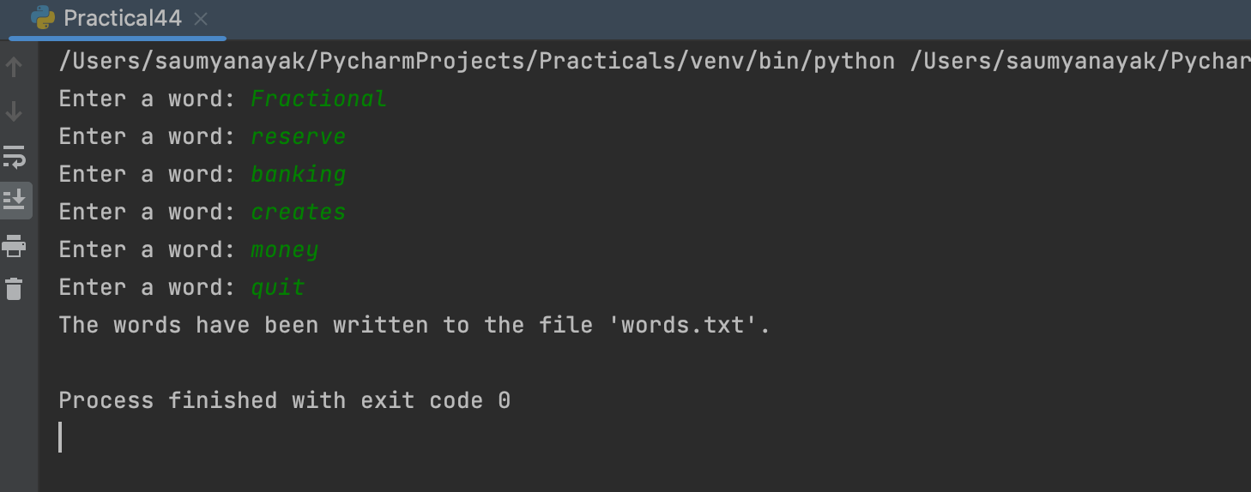

Saumya Ranjan Nayak Page 91

Programming in Python MCA 2nd Semester

Practical No. 45
Program : Write a Python program that reads a file in text mode and counts the number of words that contain anyone of the letters [‘w’, ‘o’, ‘r’, ‘d’, ‘s’].

Code Section :
with open('words.txt', 'r') as file: word_count = 0
for line in file:
words = line.strip().split() for word in words:
for letter in ['w', 'o', 'r', 'd', 's']: if letter in word:
word_count += 1 break

print(f'The number of words containing any of the letters w, o, r, d, s is
{word_count}')

Saumya Ranjan Nayak Page 92

Programming in Python MCA 2nd Semester

Output Section :

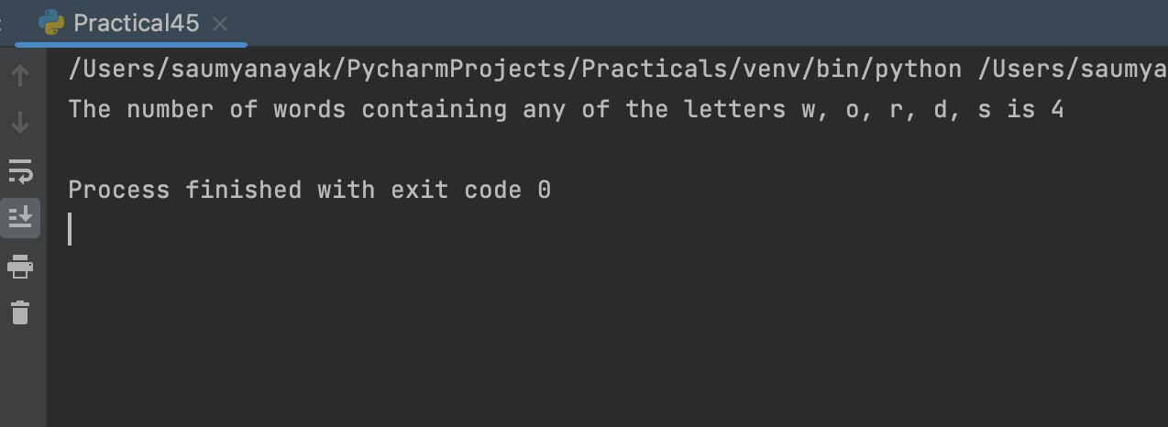

Saumya Ranjan Nayak Page 93

Programming in Python MCA 2nd Semester

Practical No. 46
Program : Python programs to demonstrate the creation and use of “modules”.

Code Section :
//mymodule def say_hello():
print("Hello from mymodule!")

//importing module import mymodule

mymodule.say_hello()

Saumya Ranjan Nayak Page 94

Programming in Python MCA 2nd Semester

Output Section :

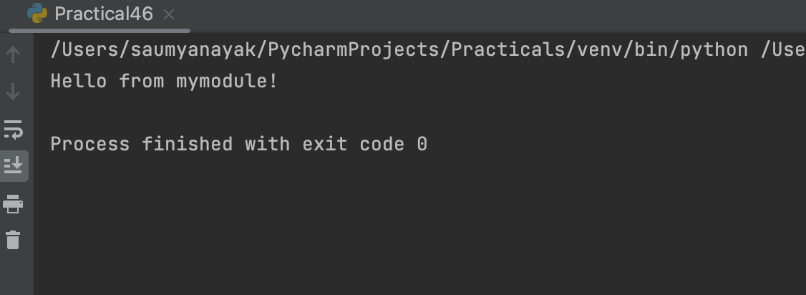

Saumya Ranjan Nayak Page 95

Programming in Python MCA 2nd Semester

Practical No. 47
Program : Exception Handling Program that uses try and except.

Code Section :
while True: try:
x = int(input("Enter a number: "))
y = int(input("Enter another number: ")) result = x / y
print("Result:", result) break
except ValueError:
print("Invalid input, please enter a number.") except ZeroDivisionError:
print("Cannot divide by zero, please enter a non-zero value for the second number.")

Saumya Ranjan Nayak Page 96

Programming in Python MCA 2nd Semester

Output Section :

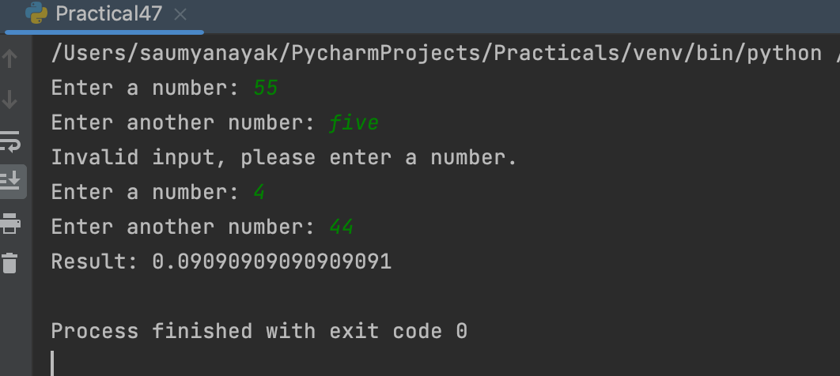

Saumya Ranjan Nayak Page 97

Programming in Python MCA 2nd Semester

Practical No. 48
Program : Exception Handling Program that handles multiple types of exceptions.

Code Section :
try:
# Code that may raise an exception num1 = int(input("Enter a number: "))
num2 = int(input("Enter another number: ")) result = num1 / num2
print("The result is:", result)

except ValueError:
print("Invalid input. Please enter a number.")

except ZeroDivisionError: print("Cannot divide by zero.")

except Exception as e: print("An error occurred:", e)

Saumya Ranjan Nayak Page 98

Programming in Python MCA 2nd Semester

Output Section :

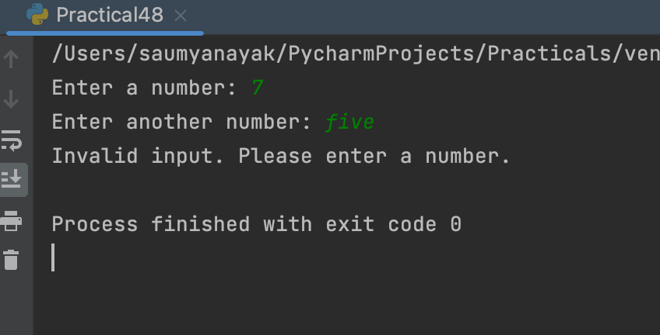

Saumya Ranjan Nayak Page 99

Programming in Python MCA 2nd Semester

Practical No. 49
Program : Exception Handling Program that uses try, except and else.

Code Section :
def divide_numbers(a, b): try:
result = a / b
except ZeroDivisionError:
print("Error: Cannot divide by zero") else:
print(f"{a} / {b} = {result:.2f}")

# Example usage:
divide_numbers(10, 5) # Output: 10 / 5 = 2.00 divide_numbers(10, 0) # Output: Error: Cannot divide by zero

Saumya Ranjan Nayak Page 100

Programming in Python MCA 2nd Semester

Output Section :

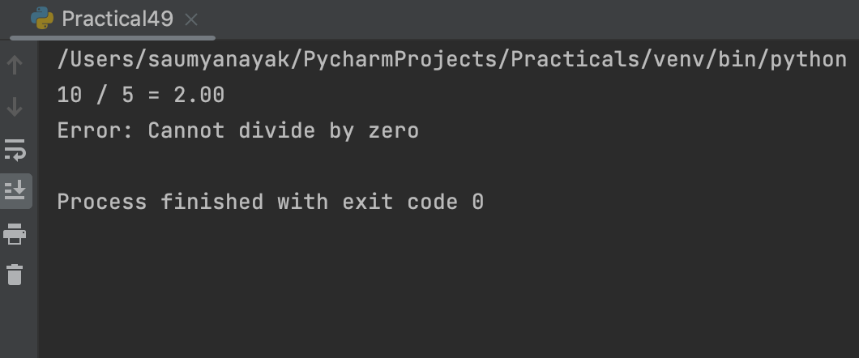

Saumya Ranjan Nayak Page 101

Programming in Python MCA 2nd Semester

Practical No. 50
Program : Exception Handling Program that uses finally with try.

Code Section :
try:
num = int(input("Enter a number: ")) result = 10 / num
print("Result:", result) except ValueError:
print("Invalid input. Please enter a number.") except ZeroDivisionError:
print("Cannot divide by zero.") else:
print("No exception occurred.") finally:
print("Program executed.")

Saumya Ranjan Nayak Page 102

Programming in Python MCA 2nd Semester

Output Section :

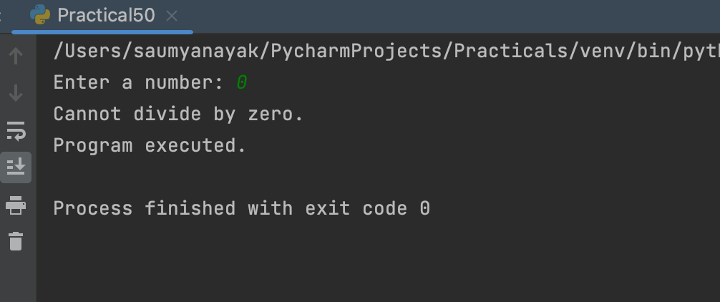

Saumya Ranjan Nayak Page 103

Programming in Python MCA 2nd Semester

Practical No. 51
Program : Write a Python program that creates a class “Person”, with attributes [aadhar, name, DoB]

Code Section :
class Person:
def init (self, aadhar, name, DoB): self.aadhar = aadhar
self.name = name self.DoB = DoB

def display(self): print("Aadhar:", self.aadhar) print("Name:", self.name)
print("Date of Birth:", self.DoB)

# Create an instance of the Person class
p = Person("1234-5678-9012", "John Doe", "01/01/2000")

# Display the details of the person p.display()

Saumya Ranjan Nayak Page 104

Programming in Python MCA 2nd Semester

Output Section :

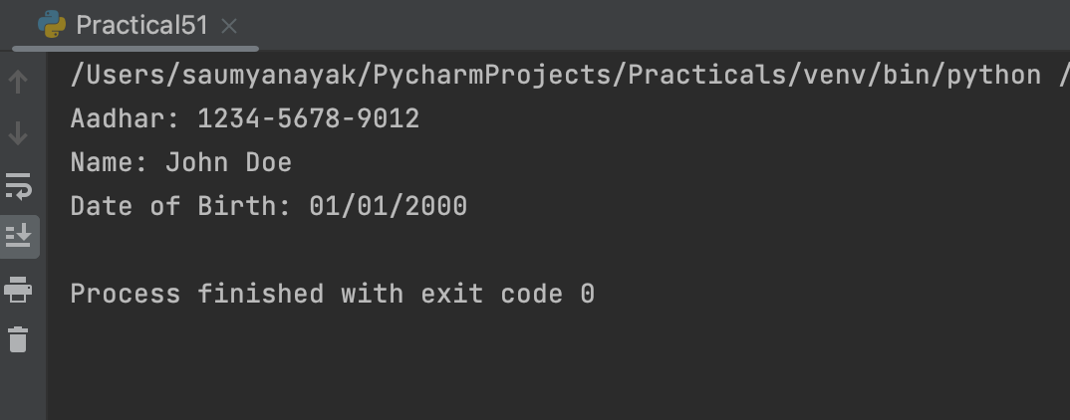

Saumya Ranjan Nayak Page 105

Programming in Python MCA 2nd Semester

Practical No. 52
Program : Write a Python program that creates classes “Point” and “Rectangle” where the Rectangle class has a Point object as its attribute.

Code Section :
class Point:
def init (self, x, y): self.x = x
self.y = y

class Rectangle:
def init (self, p1, p2): self.p1 = p1
self.p2 = p2

def area(self):
width = abs(self.p2.x - self.p1.x) height = abs(self.p2.y - self.p1.y) return width * height

# example usage p1 = Point(2, 3) p2 = Point(5, 7)
rect = Rectangle(p1, p2) print(rect.area()) # prints 12

Saumya Ranjan Nayak Page 106

Programming in Python MCA 2nd Semester

Output Section :

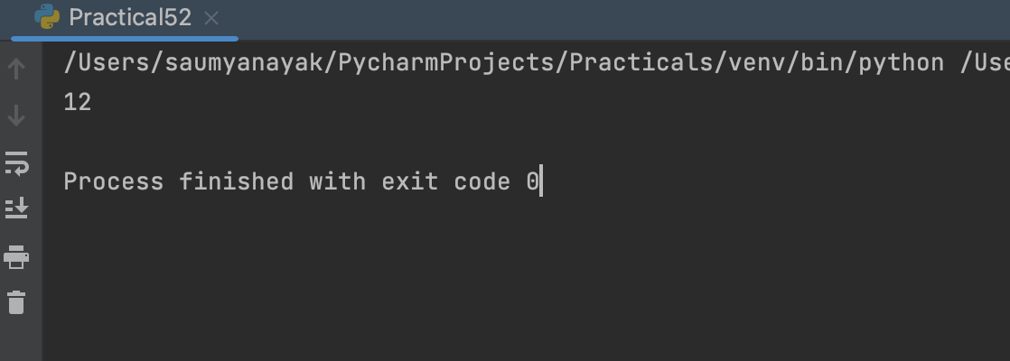

Saumya Ranjan Nayak Page 107

Programming in Python MCA 2nd Semester

Practical No. 53
Program : Write a Python program that creates a class Students which inherits the properties of the “Person” class; add attributes [roll_no, class].

Code Section :
class Person:
def init (self, aadhar, name, dob): self.aadhar = aadhar
self.name = name self.dob = dob

class Students(Person):
def init (self, aadhar, name, dob, roll_no, class_name): super(). init (aadhar, name, dob)
self.roll_no = roll_no self.class_name = class_name

def display(self): print("Aadhar:", self.aadhar) print("Name:", self.name)
print("Date of Birth:", self.dob) print("Roll Number:", self.roll_no) print("Class:", self.class_name)

# creating object of Students class and displaying its details
s = Students("123456789012", "John Doe", "2005-01-01", "101", "10th")
s.display()

Saumya Ranjan Nayak Page 108

Programming in Python MCA 2nd Semester

Output Section :

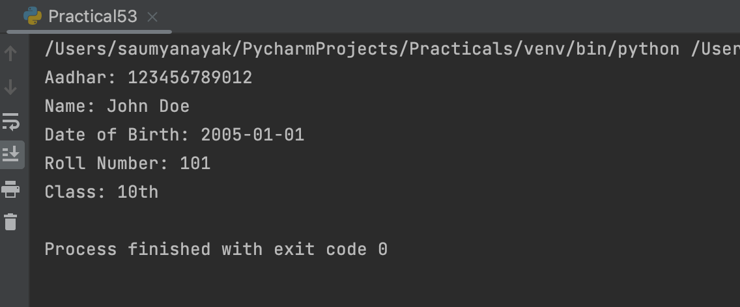

Saumya Ranjan Nayak Page 109

Programming in Python MCA 2nd Semester

Practical No. 54
Program : Write a Python program to demonstrate “Multiple Inheritance”.

Code Section :
# Defining the parent classes class A:
def method_a(self): print("This is method A")

class B:
def method_b(self): print("This is method B")

# Defining the child class which inherits from both A and B class C(A, B):
def method_c(self): print("This is method C")

# Creating an object of class C obj = C()

# Calling the methods of A, B, and C using the object of C obj.method_a()
obj.method_b() obj.method_c()

Saumya Ranjan Nayak Page 110

Programming in Python MCA 2nd Semester

Output Section :

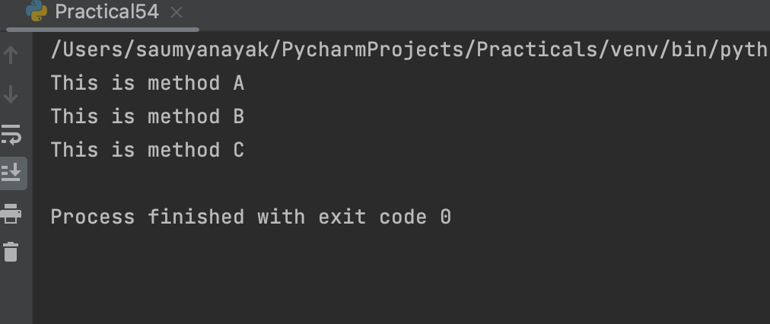

Saumya Ranjan Nayak Page 111

Programming in Python MCA 2nd Semester

Practical No. 55
Program : Write a Python program to demonstrate “Method Overriding”.

Code Section :
class Animal:
def move(self): print("I can move.")

class Dog(Animal): def move(self):
print("I can run and walk.")

class Fish(Animal): def move(self):
print("I can swim.")

# create objects of the classes animal = Animal()
dog = Dog() fish = Fish()

# call the move() method on each object animal.move() # prints "I can move." dog.move() # prints "I can run and walk." fish.move() # prints "I can swim."

Saumya Ranjan Nayak Page 112

Programming in Python MCA 2nd Semester

Output Section :

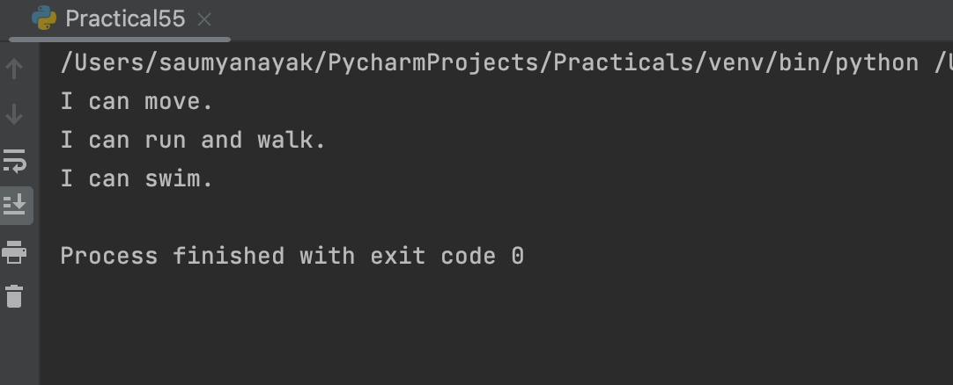

Saumya Ranjan Nayak Page 113

Programming in Python MCA 2nd Semester

Practical No. 56
Program : Write a Python program to demonstrate “Method Overloading”.

Code Section :
class Calculator:
def add(self, a, b, c=0, d=0): return a + b + c + d

calc = Calculator()

print(calc.add(2, 3))
print(calc.add(2, 3, 4))
print(calc.add(2, 3, 4, 5))

Saumya Ranjan Nayak Page 114

Programming in Python MCA 2nd Semester

Output Section :

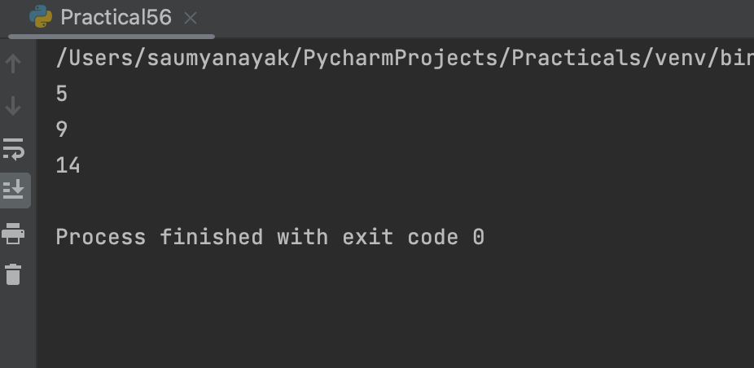

Saumya Ranjan Nayak Page 115

Programming in Python MCA 2nd Semester

Practical No. 57
Program : Write a Python program to demonstrate “Operator Overloading” [+ and -] using a class “Book”.

Code Section :
class Book:
def init (self, title, author, pages): self.title = title
self.author = author self.pages = pages

def str (self):
return f"{self.title} by {self.author}"

def add (self, other):
new_title = f"{self.title} and {other.title}" new_author = f"{self.author} and {other.author}" new_pages = self.pages + other.pages
return Book(new_title, new_author, new_pages)

def sub (self, other):
new_title = f"{self.title} without {other.title}" new_author = self.author
new_pages = self.pages - other.pages
return Book(new_title, new_author, new_pages)

book1 = Book("The Alchemist", "Paulo Coelho", 197)

Saumya Ranjan Nayak Page 116

Programming in Python MCA 2nd Semester

book2 = Book("The Catcher in the Rye", "J.D. Salinger", 224) book3 = Book("To Kill a Mockingbird", "Harper Lee", 281)

# adding two books new_book = book1 + book2 print(new_book)
print(f"Total pages: {new_book.pages}")

# subtracting one book from another new_book = book3 - book2 print(new_book)
print(f"Total pages: {new_book.pages}")

Saumya Ranjan Nayak Page 117

Programming in Python MCA 2nd Semester

Output Section :

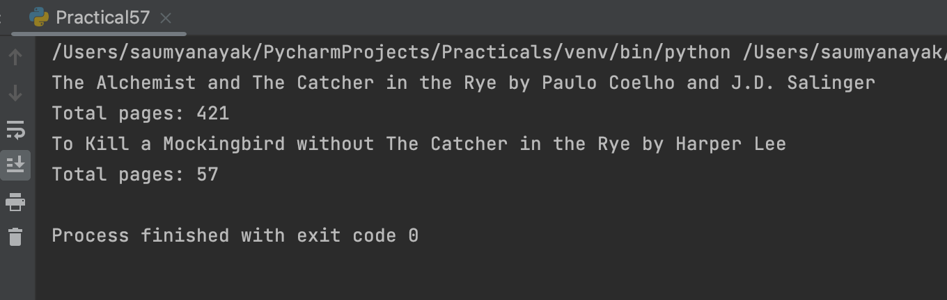

Saumya Ranjan Nayak Page 118

Programming in Python MCA 2nd Semester

Practical No. 58
Program : Use the “turtle” module to draw concentric circles with different colours.

Code Section :
import turtle

colors = ["red", "green", "blue", "purple", "yellow"] turtle.speed(0)

for i in range(5): turtle.color(colors[i]) turtle.penup() turtle.goto(0, -i * 20) turtle.pendown() turtle.circle(20 * (i + 1))

turtle.done()

Saumya Ranjan Nayak Page 119

Programming in Python MCA 2nd Semester

Output Section :

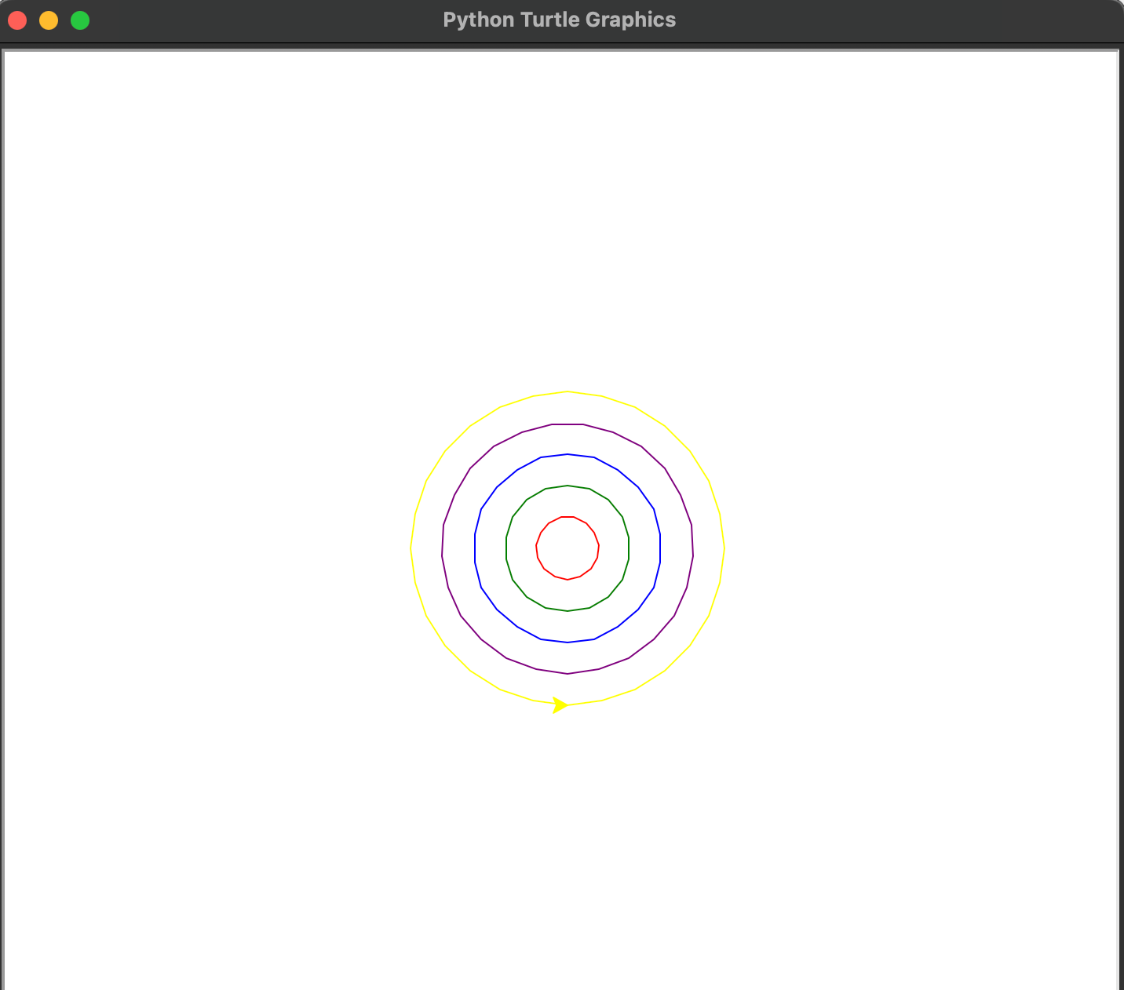

Saumya Ranjan Nayak Page 120

Programming in Python MCA 2nd Semester

Practical No. 59
Program : Use the “turtle” module to print the multiplication table.

Code Section :
import turtle

# Set up the turtle t = turtle.Turtle() t.speed(0)

# Define a function to draw a single multiplication table def draw_table(num, x, y):
t.penup()
t.goto(x, y) t.pendown()
for i in range(1, 11):
t.write("{} x {} = {}".format(num, i, num * i)) t.penup()
t.goto(x, y - i * 20) t.pendown()

# Draw the multiplication tables for i in range(1, 11):
draw_table(i, i * 50, 0)

# Keep the turtle window open turtle.done()
Saumya Ranjan Nayak Page 121

Programming in Python MCA 2nd Semester

Output Section :

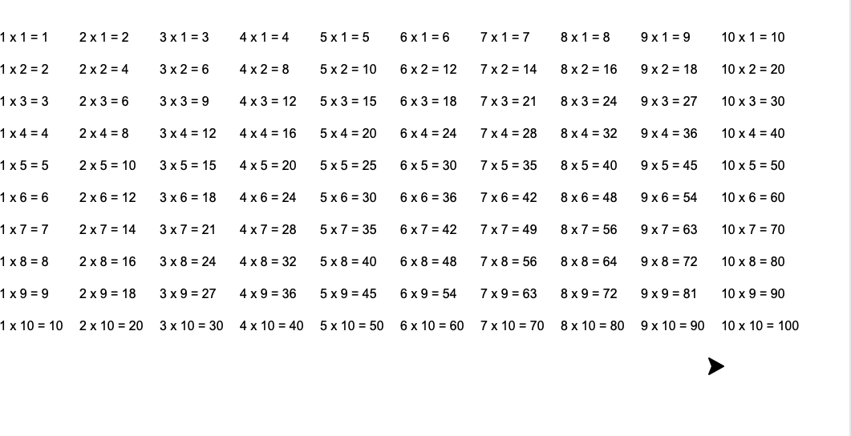

Saumya Ranjan Nayak Page 122

Programming in Python MCA 2nd Semester

Practical No. 60
Program : Use the “turtle” module to draw (not write) your name.

Code Section :
import turtle as t t.pen t.backward(200) t.undo()
t.penup() t.backward(250) t.pendown()
#S
t.forward(50) t.left(90) t.forward(25) t.left(90) t.forward(50) t.right(90) t.forward(25) t.right(90) t.forward(50) t.penup()
t.goto(150,0)
t.undo() #A
t.goto(-150,0)
t.left(90)
Saumya Ranjan Nayak Page 123

Programming in Python MCA 2nd Semester
t.pendown() t.forward(50) t.right(90) t.forward(40) t.right(90) t.forward(50) t.backward(50) t.forward(25) t.right(90) t.forward(50) t.undo() t.forward(40) t.penup()
#U
t.goto(-70,0) t.right(90) t.forward(50) t.pendown() t.backward(50) t.right(90) t.forward(40) t.left(90) t.forward(50) #M
t.goto(20,0)
t.undo()
Saumya Ranjan Nayak Page 124

Programming in Python MCA 2nd Semester
t.penup()
t.goto(20,0) t.pendown() t.forward(50) t.right(90) t.forward(20) t.right(45) t.forward(25) t.left(90) t.forward(25) t.right(45) t.forward(20) t.right(90) t.forward(50) t.penup()
#Y
t.goto(120,0)
t.goto(140,0) t.left(180) t.pendown() t.forward(25) t.left(45) t.forward(25) t.backward(25) t.right(90) t.forward(25)
Saumya Ranjan Nayak Page 125

Programming in Python MCA 2nd Semester
t.penup() #A
t.goto(190,0) t.left(45) t.pendown() t.forward(50) t.right(90) t.forward(40) t.right(90) t.forward(25) t.right(90) t.forward(40) t.backward(40) t.left(90) t.forward(25)

Saumya Ranjan Nayak Page 126

Programming in Python MCA 2nd Semester

Output Section :

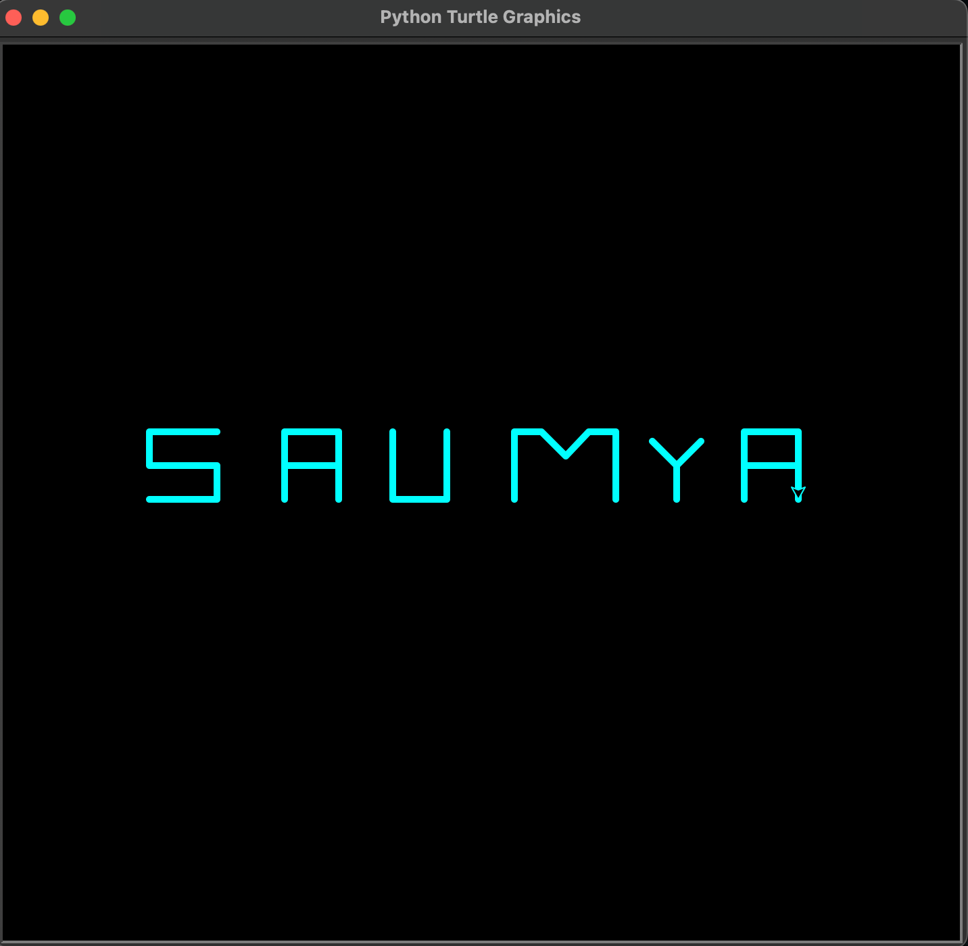

Saumya Ranjan Nayak Page 127

